**A CASE STUDY OF JOINT ADMISSIONS AND MATRICULATION BOARD (JAMB)**

**FILE TRACKING SYSTEM (FTS)/DISPATCH MANAGEMENT SYSTEM (DMS)**

**BY**

**B DEBORAH ALONGE**

**MATRIC. NO: 1840803034**

**NOVEMBER, 2021**

**NOVEMBER, 2021**

**FILE TRACKING SYSTEM (FTS)/DISPATCH MANAGEMENT SYSTEM (DMS)**

**A CASE STUDY OF JOINT ADMISSIONS AND MATRICULATION BOARD (JAMB)**

***BY***

**(B DEBORAH ALONGE)**

**MATRIC. NO: _____1840803034_____**

**A THESIS SUBMITTED TO THE POST GRADUATE SCHOOL, UNIVERSITY OF ABUJA.**

**IN PARTIAL FULFILMENT OF THE REQUIREMENT FOR THE AWARD OF MASTERS OF SCIENCE IN COMPUTER SCIENCE (____________________________)**

**NOVEMBER, 2021**

**CERTIFICATION**

I certifiedthat this project work was supervised, accepted and approved in partial fulfillment of the requirement for the award of Masters of Science (M.Sc) degree in Computer Science, University of Abuja.

**­­­­­­­­­­­­­_________________________ __________________**

**Dr Mrs AMINAT AJIBOLA Date**

**Supervisor I**

**_________________________ __________________**

**Dr E. Omolara Date**

**Supervisor II**

**­­­­­­­­­­­­­**

**_________________________ __________________**

**Dr H. I Bisallah**

**Date**

**Head of Department**

**­­­­­­­­­­­­­_________________________ __________________**

**Name Date**

**External Examiner**

**­­­­­­**

**_________________________ __________________**

**Name Date**

**Dean, Faculty of Science**

**_________________________ __________________**

**Name Date**

**Dean, Post Graduate School**

ACKNOWLEDGEMENT

**APPROVAL PAGE**

The attached research project by **__________________**, entitled ____________________, when completed, is to be submitted to the Post Graduate School, University of Abuja in partial fulfillment of the requirements for the Masters of Science in _________ degree, for which six (6) credits shall be allowed is hereby:

**Approved**: _____________________________ Date: _________________

**(Supervisor’s name)**

**DECLARATION OF AUTHORSHIP**

I, **________________** declare that this thesis on “________________________________” carried out by me under the supervision of __________________ has not been presented for award of any degree in any institution. All sources of information are specifically acknowledged by means of reference.

____________________________. ­­­­­­­­­­­­­­­­________________________

**(B DEBORAH ALONGE) Date**

**STUDENT**

# **Abstract**

Large volumes of data are usually generated in most government and corporate organizations today. Locating files among a large number of others can be time-consuming and laborious process for both administrative and staff member of such organization. The aim of this paper is to design and implement a web-based file tracking system with dispatch management system to improve productivity amongst Core administrative personnel. The FTS developed in this paper is a web application that is able to manage the creation, and movement of files from desk to desk of personnel who work on them. The system was developed with visual studio software after establishing vital functional and non-functional requirements and detailed workflows. Files, such as, memo, proposal, requests, reports can be processed and tracked by the system in real-time. The system when implemented shall improve efficiency and effectiveness of the existing system, consistency of file records, resource management, and quality of administration. It will give room for transparency and accountability and thereby will help to reduce turnaround time, and disallows the delays of files. Furthermore, the system helps in online tracking and provides location information. The system is interactive and usable and able to improve file management and productivity in either government or private organization operations.

Table of Contents

Abstract 6

CHAPTER ONE INTRODUCTION 10

1.1 Background of the Study 10

1.2 Statement of the Problem 11

1.3 Aim and Objectives of Study 11

1.4 Significance of Study 12

1.5 Scope of the study 12

1.6 Organization of Project 15

1.7 Limitations of the Existing System 15

1.8 Research questions of the study 15

CHAPTER TWO LITERATURE REVIEW 16

2.8 **Document Management/File Tracking System** 16

2.2 **Basic Aspect of Computer Security** 18

2.2.1 **Confidentiality** 18

2.2.2 **Integrity** 18

2.2.3 **Availability** 19

2.3 **Waterfall model** 19

2.3.1 **Advantages of the waterfall Model** 19

2.3.2 **Disadvantages of the Waterfall Model** 19

2.1 **The Modified Waterfall Model** 20

2.4 **Review of Related Existing System** 20

2.3 **Review of Related Research Works** 22

2.6 **Summary of Limitation of the Reviewed Research Works** 25

CHAPTER THREE SOFTWARE ANALYSIS AND DESIGN 27

**Limitations of the Existing System** 27

**Justification of the New System** 27

3.1 **SYSTEM ANALYSIS** 27

3.2 **DESIGN MODEL USED** 28

3.2.1 **Analysis Phase** 28

3.2.2 **Tools and Selection Phase** 29

3.2.3 **Design Phase** 29

3.2.4 **Implementation Phase** 29

3.2.5 **Post Implementation Phase** 29

3.3 **Functional Requirement** 29

3.4 **Software Requirement** 31

3.4.1 **Visual Studio Code** 31

3.4.2 **ASP.NET** 31

3.4.3 **Microsoft SQL** 31

3.4.4 **HTML** 31

3.4.5 **JavaScript** 32

3.4.6 **Cascading Style Sheets (CSS)** 32

3.4.7 **JQuery** 32

**3.5** **Design Architecture** 32

**3.5.1** **The 3-tier Architecture** 33

**3.6** **UML Diagrams** 35

**3.6.1** **Use Cases** 35

3.2 **SEQUENCE DIAGRAM** 39

3.8 Class Diagram 41

CHAPTER FOUR IMPLENTATION 42

**4.1** **System Hardware** 42

**4.2** **System Software Requirement** 42

**4.3** **Data Source** 42

For this work data was source from the following: 42

➢ Different departments of Joint Admissions and Matriculation Board (JAMB) 42

➢ The internet to research closely related works 42

➢ Libraries 42

➢ Advance Programming in Visual Studio 42

**Database Structuring** 42

**SERVER SIDE** 43

4.1 Demonstration 46

4.2 Evaluation Result 53

4.2.1 Technical Evaluation 53

4.2.2 Users Evaluation 53

4.2.2.1 Method 53

4.7.2.2 Result 53

CHAPTER FIVE CONCLUSION AND RECOMMENDATION 56

**5.1** **Conclusion and Summary Result** 56

**5.2** **Recommendation** 56

**5.3** **Contribution to the knowledge** 56

**5.2** **Suggestion for future research** 56

REFERENCES 58

Table 1 Old system of Jamb FTS can expect to reap form the use of FT/DMS 12

Table 2: Use case description 13

Table 3 Tracking Systems Comparison. 26

Table 4 Overview of Memo Table 43

Table 5 Overview of Users Table 43

Table 6 Overview of Department Table 43

Figure 1: Use case diagram showing the current document tracking and management system in JAMB. 13

Figure 2 - A use case diagram of the Administrator (Super-Administrator) 36

Figure 3- A use case diagram of Head of Department 37

Figure 3.4 - A use case diagram of Head of Department 38

Figure 5 department management class diagram 41

Figure 6 Data Layer 44

Figure 7 Business Layer 44

Figure 8 Password Encryption 45

# **CHAPTER ONE INTRODUCTION**

Nowadays, locating files is one of the most difficult tasks in JAMB. Time is wasted archiving or searching for files, energy is wasted chasing misplaced files, deadlines are missed and sometimes files are lost. Presently, there is no any automated system in place in JAMB to track the status of any physical file.

The need to keep track of files has become significantly important today particularly in most government and corporate organizations, misplace or theft of confidential documents causes significant impact on the business and secrecy of an organization information. File Tracking System/Document Management System offers clear visibility of the file movement throughout the file processing channel [1]. Sometimes there is need for a file to go through several personnel before it can be rendered acceptable. There are however drawbacks in transferring these files from one desk to another such as getting these documents/files missing or forgetting to document the transfer. There is thus need for a system that can provide solutions that will address such problems while saving time and energy of administrative workers. File tracking systems (FTS) offer a viable solution in this regard. The effectiveness and efficiency of any organization depends on its ability to efficiently manage its files and documents. Therefore, retrieval, searching and locating of a file or document should be carried out with little or no stress [2]

This project is aimed to develop a web-based File Tracking/Dispatch Management System application to monitor the movement of files and assist in their easy tracking and dispatch. Its features include generation of documents/files, updating its status, opening of new files, tracking the movement of files, dispatching memos/letters/files, recording their track, etc. To do this, a thorough investigation on the flaws of the existing system has to be done and be addressed throughout the development process. This project is crucial to ensure that the organization is able to efficiently deliver, maintain and manage the system hence bettering service quality.

## Background of the Study

The current condition for document management/file tracking system is managed manually by administrative staff of Joint Admissions & Matriculation Board (JAMB). This project explores the scope and importance of FTS/DMS in detail and illustrates the three major modules that will be used in this project: Administrator module, Director Module, and Dispatcher Module (Secretary Module). These modules will be discussed in details in later chapter of this project. The project suggests what administrators can do now to begin preparing for this major advancement in information management. The roles of the FTS/DMS are: Each document can be logically registered, preserved, retrieved and renewed at high speed while tracing the required documents or files.

Thus, efficiently performing an office work, reducing a volume of consumed paper and minimizing a work space in an office. Improvement of functions and operations in the document management systems are been required with the spread of the system in many offices to assist the organization in the use of information technology.

## **Statement of the Problem**

Currently there is no existing software which is capable of locating files, memos, and reports within the organization**.** JAMB still manage itsfiles and documents using the manual method, such method lack effective and efficient ways ofrecording, tracking, retrieving and managing files and documents that are moved from one place toanother within the organization. When a file is needed, it can only be obtained in a physical form. This is a disadvantage as only the offer in charge have access to the storage.

When a file or documents are stored by physical mean, it is more likely to be exposed to threat (modification). In the process of moving such files or documents, they can beintentionally/unintentionally misplaced or lost which makes missing files and documents difficult totrack in the manual file management method. The organization has no equipment in the storage area such as sensors and anti-theft alarm that are expensive in cost in case hacker or anonymous user have access to the storage area. Also, when someone need to get the documents, he or she has to be physically present at the storage location to personally take it. This consumes time that can be otherwise channeled to other beneficial activities. Also, the susceptibility for misplaced, missing or stolenfiles is high when such organization as Jamb uses the manual file and document management system (Omoregbe etal. 2014). However, in the case of misplaced files, locating them is usually more difficult andcumbersome. Hence, the need to keep track of files is the source of motivation for this research work. The research aims at providing an electronic solution to most of the aforementioned weaknesses of the manual file and document management system. Effective and efficient files and documents management is at the heart of any established organization which enhances the organization’s productivity and performance (Moran and Morner, 2O~7).

## **Aim and Objectives of Study**

The FT/DM system is to assist the organization in achieving their objective of an efficient, effective, and user friendly file tracking system. To verify and validate the developed system is usable and meets up the standard defined prior to development. This will provide an environment where the user can track the whole life cycle of the movement of the file. Before the current system had been implemented, the document in the organization was being sent manually from one department to another. All the administrative staffs and department were having separate record of the movement of the files in form of hardcopy. They were maintaining a register, there were no records in digital form. Whenever required information about any specific file likes: - the current location of the file, or who has initiated the file. It was almost impossible, and if possible then it was time consuming. The situation became worst for the departments like Humane Resource Department, Information Tech Department, Quality Assurance Department because they have huge number of files. These departments sometimes need information of a file in a moment. So, it was very tedious job to manage track the location of the files.

## **Significance of Study**

Proper tracking and retrieval of file and document will eliminate missing file cases and invariably reduce any corrupt practices, nepotism and favoritism found in the organization. The system when implemented shall improve efficiency and effectiveness of the existing system, consistency of file records, resource management, and quality of administration. It will establish transparency and accountability and thereby will help to reduce turnaround time, and processing delays of files. In general, the significant or benefit of this project is to manage the file or documents in Jamb through web-based application which enable the users ease in retrieving the documents.

|  |  |
| --- | --- |
| Problem/Issue FDTS Impact | FT/DMS Impact |
| Missing or lost files/documents. | Electronic files, if indexed and backed-up properly, will not get lost. |
| Take long time to retrieve required documents (lost documents). | The documents will be linked to cases as soon as they are scanned and indexed. Available to users immediately. |
| File available to only one user at a time. | Electronic files are available to multiple users at the same time. |
| Documents are copied to circulate. | The need for extra copies will be eliminated |

Table 1 Old system of Jamb FTS can expect to reap form the use of FT/DMS

## **Scope of the study**

**Current system scope**

JAMB is an organization that has about 1800 staffs, this comprises of the administrative staff: the directors, the deputy directors, assistant deputy directors, head of divisions and others. Secretary/clerk of each department as mentioned above are responsible for the document in and out to/from the organization.

This paper study the most effective ways of building an online resources web site for JAMB by examining the existing system and determining the requirements.

For this project, the **Waterfall model with UML notation** was used in order to analyze the system. The scope of the File Tracking /Document Management System in JAMB has been analyzed and is shown by using a use case diagram. Figure 1 shows a use case diagram of the current system of the Document Management System.

The description of the use case diagram is listed in the Table 2 below.

|  |  |
| --- | --- |
| Send document | The department will receive document from sender either from own staff or outside organization. |
| Record document | The staff (system) that responsible for the document will record the document and keep the document in a respective file. |
| Request for document | The receiver will request for the document and the staff responsible need to make sure that the documents are in a file for easy retrieval and can be access easily. |

Table 2: Use case description

**Current DMS in JAMB**

Receiver

Sender

Figure 1: Use case diagram showing the current document tracking and management system in JAMB.

**Analysis of current system**

This section I will discuss about the data collection on current system of JAMB Document Management and File Tracking System which currently handled manually by the user(s) in charge of each departments. Issues regarding the current system were analyzed and explained with more detailed in next chapter.

The Organization consist of various departments, The Registrar Office, Information and Technology Department (ITS), Test-Administration (TA), Test-Development (TD), ADMISSION, Human Resources (HR), Quality Assurance (QA), General Services (GS), Psychometric, Special Duties (SD). Other offices are State/Zonal offices, which are mostly located across 37 states of the federation. Every office in the state offices is head by a state coordinator or zonal director as the case maybe and they maintain dozens of files housed within them to maintain records in categorized manner.

#### Category of Document

The type of document to or from the department/office includes memo, circulation, letter from outside organization or other department and others.

#### Current Document /File Tracking System

The users of the documents consist of registrar, director/head of each department/office. Two major transactions involved in the current system namely user record and manage the document received and user request for document. Each copy of the document needs to be kept in a file for future references.

**Users Roles and Responsibilities**

The roles and responsibilities of the related users that is using this system are as follows:

#### Sender/Dispatcher

The sender of the document can be categorized into three categories namely staff

Administrative staffs, Directors from others departments and Secretary.

When a document is minute to a director from a particular department to any other department, the dispatcher (secretary) takes it to the appropriate department and hand it over to the clerk/ secretary of that department or to the director himself in case the document contains a sensitive information.

#### Receiver

The receiver of the document can be categorized into two categories namely staff (director/

Administrative staffs), and secretary.

**Proposed System**

The proposed File-Tracking/Dispatch Management System will not disturb the existing file movement system; however, file dispatch and receive procedures will be computerized. The existing files (Long Term files) will be recorded electronically as well as new files will be created to track their movement. There will be no change in the existing locally save system. The proposed file tracking-system will involve all entities of the existing system except dispatch registers, which will be replaced electronically and will be file in a database. In addition to them, it will require “Super Administrator”, “Administrators” and “normal user”. Each type of user will be assigned specific roles to maintain the system. To ensure role-based security, after deployment of the system. The system will be exclusively controlled by Super Administrators. However, there will be scope of improvement and future modification.

## **Organization of Project**

In this paper I will discuss following points one by one: Architecture of the system like the technology, framework, and database and deployment description. Then I will discuss about approach used to develop the system, the organization structure on which the system has been implemented, feature of the system, work flow of the system, time duration for the system implementation, manpower, different milestones, future aspects of the system, then conclusion and at last reference.

## **Limitations of the Existing System**

Before the current system had been implemented, the document in the JAMB was being sent manually from one department to another. All the employees were having separate record of the movement of the files in form of hardcopy. They were maintaining a register. There were no records in digital form. Whenever required information about any specific file likes: - the current location of file. The user in charge will manually have to search through the file index and so on.

## **Research questions of the study**

The purpose of this study is to describe why tracking has become so vital in JAMB, identify the key problems with current designs of tracking systems, and develop and test a solution proposal that addresses the identified problems. Based on the identified shortcomings in previous study research and current tracking systems, the following explicit research questions were defined.

First, some weaknesses were identified as previously stated: no software which is capable of locating files, memos, and reports in JAMB. Furthermore, the lack of previous empirical results covering some of the identified benefits, and the wideness of potential uses of tracking systems and information justify explorative research on the reasons of using tracking systems and gathering tracking information. Therefore we can formulate the first research question (research question 1) of the thesis as: “What can be obtained by using file tracking and document management systems?”

The second identified shortcoming was the inability to replace the traditional or conventional tracking system and the lack of solution proposals addressing the challenges of storing files. The second research question (research question 2) of the thesis is thus formulated as: “How to design File tracking/Document management system?” The answer to this question is web based file tracking (FT)/document management system solution concept describing system attributes required for successful application of file tracking/document management systems.

# **CHAPTER TWO LITERATURE REVIEW**

In this chapter a review of the literature about Document Management Systems would be provided as motivation for this work. In the first section of this chapter, research about the evolution of document management would be discussed. This would be followed by a discussion of research that focused on water fall model advantage and disadvantages of the model. Discussion on related works in the field of work will be treated.

## **Document Management/File Tracking System**

There are several definitions for Document Management System, they are:

* Document Management System: Originally, a document management system is a computer program (or set of programs) use to track and store images of paper documents. More recently, the term has been used to distinguish between imaging and records management systems that specialize in paper capture and records respectively. Document management systems commonly provide check-in, check-out, storage and retrieval of electronic documents often in the form of word processor files and the like [12**].**
* Document Management System: Handles documents by electronically storing, organizing, indexing and filing. They can be retrieved when required, without any loss of time. It uses imaging technology to enable access to the unstructured data, it brings all documents to your desktop and enables you to work with them, eliminating the need for paper-based documents and it is a powerful document archival system, which ensures safety of documents, faster access to them and huge cost savings [6]**.**

With these definitions above, it can simplify that a Document Management System is a process of documenting a document to a proper location and storage. Document management systems commonly provide storage, versioning, metadata, security, as well as indexing and retrieval capabilities. It is done so that it will be easier for the organization to retrieve and use the data efficiently and effectively. It reduces time, faster access and saves human cost. Because of this characteristic, Document Management System must also have a good security system and easy interface level so that it is safe and environment friendly to use.

1. **Evolution of Document Management System**

In the early days of document management, businesses and individuals had to keep all their files in filing cabinets. This allows for files to be stored in an understandable system. However, the systems became cumbersome, due to the huge amount of space that was used. Large companies would have entire rooms or whole storage areas full of filing cabinets for all of their paperwork. This was extremely inefficient; each file that came in needed to be filed, costing the business resources and time. In addition to that, if a file ever needed to be accessed, the company would have to spend more time, energy, and resources trying to find it. Sometimes this could take hours, and often ended in futility. The physical copies of the documents were difficult to deal with. There were a number of problems that companies faced in regards to the files they kept. These files could be stolen or misplaced. On top of this, there was the threat of disaster such as a flood or fire. These tragedies would eliminate all documentation, making true document management impossible. Beginning in the 1980s, a number of vendors began developing software systems to manage paper-based documents. These systems dealt with paper documents, which included not only printed and published documents, but also photographs, prints etc. [22]. Computers were becoming available to companies. Along with the computers, businesses could get document management storage, which would allow them to start keeping important files on the computer. Later developers began to write a second type of system which could manage electronic documents, i.e., all those documents, or files, created on computers, and often stored on users' local file-systems. The earliest electronic document management (EDM) systems managed either proprietary file types, or a limited number of file formats. Many of these systems later became known as document imaging systems, because they focused on the capture, storage, indexing and retrieval of image file formats. EDM systems evolved to a point where systems could manage any type of file format that could be stored on the network. The applications grew to encompass electronic documents, collaboration tools, security, workflow, and auditing capabilities. This decade, there are a number of options when it comes to document management; some of these systems are user-friendly while some are not. However little is being discussed about the Document management and its security.

Document security has long been a concern of organizations. Regardless of format or whether analog or digital, business records, sensitive data and proprietary information have needed to be secured in order to protect the interests of the organization. As the need for such security has expanded with the introduction of the digital age, more sophisticated document security management systems have been developed, boasting more complex methods of securely storing and retaining myriad business documents.

**External Threats**

In the digital age, the rise of hackers, viruses, phishing and other potential data security threats have created the need for more secure IT systems and related safeguards. The intellectual assets of an organization are vital to the health of the business, and thus there is a push to improve and refine document security management processes.

One of the biggest myths surrounding document security is that upgrading to an electronic or cloud-based document management system leaves systems susceptible to breaches. While there are data security issues in the digital sphere, there are also a number of security improvements that are the result of technology. Furthermore, failure to upgrade systems means a business will be stuck using archaic data management methods unsuitable for a digitally-driven business environment. There needs to be a balance between security and productivity, which is where document management systems excel (more on this below).

**Internal Threats**

Almost all of the concerns about document security are targeted to the external threats faced by organizations. However, equally important are internal breaches to company document security. This can take many forms, from intentional breaches of security to, more commonly, unwitting breaches to company confidentiality on the part of employees. Often, there is a lack of understanding due to the absence of (or failure to enforce) a confidentiality policy. Ensuring that a clear organization confidentiality policy is outlined and included in contracts is one aspect of a stronger document security management process. However, it is not a comprehensive solution.

By adopting the right [Document Management System](http://www.mesltd.ca/why-mes/corporate-security/), one can ensure document security while also increasing productivity within the organization. Hence, the need for a centralized system that allows you to provide access to those who need it to complete tasks, and limit access to those who do not; it also helps bolster security with top notch safeguards to help ensure that organization’s data remains safe and secure.

## **Basic Aspect of Computer Security**

There are three basic aspects in computer security: confidentiality, integrity and availability [1]. Argues that there are more aspects than these, but this work will use the view of [4]on security with only three aspects.

### **Confidentiality**

The confidentiality aspect concerns all access restrictions to information and resources. Information can be hidden or scrambled to limit the access to only concerned parties, or the information is protected by a virtual barrier enforced with for example the access control of an operating system. Existence of data may also apply to confidentiality, because the existence may reveal more than the data itself. For example if your organization normally never encrypts email, someone monitoring the trace could conclude that something is about to happen when suddenly all emails are encrypted. Hiding resources is also an important part of confidentiality, because the notion of system configuration and what operating systems are used can help an attacker to find the weakest link in your protection. Contrary to Anderson [1], secrecy and privacy is covered by the confidentiality aspect. With secrecy, it means to limit the amount of people having access to the information and privacy is the ability to protect personal secrets. Bishop makes no distinction between secrecy, privacy and confidentiality.

### **Integrity**

How much data can be trusted or the trustworthiness of data and resources is the aspect of integrity. It can be divided into data integrity, that is the integrity of the contents, and origin integrity, the source of the data is correct, which is also called authentication. Integrity violations can either be prevented or detected. A prevention mechanism tries to prohibit any unauthorized operations that attempts to change the data. A user can try to change data for which he or she is not authorized for or an authorized user can try to change the data in other ways than allowed, i.e. authorized user performing an unauthorized operation. Bishop gives a good example to explain this difference [4]**.** Suppose an accounting system is running on a computer and someone hacks into the system and tries to modify the data that is an unauthorized user tries to violate the integrity of the system. But what if a hired accountant tries to steal money by modifying the data and virtually transfer money to his own account that is an authorized user tries to perform an unauthorized operation. The detection mechanism tries not to prevent modification, rather making it possible to detect any modification violating the integrity. The data may be reported to be no longer trustworthy. Hence, Data integrity means maintaining and assuring the accuracy and consistency of data over its entire life-cycle, and is a critical aspect to the design, implementation and usage of any system which stores, processes, or retrieves data.

### **Availability**

The ability to access information or a resource is referred to availability. A service can deliberately be blocked by an attacker making this aspect a part of computer security. These attempts are called denial of service attacks, or DOS-attacks for short, and can be difficult to identify and separated from increased normal-usage. For example, if you are running a popular web site and suddenly one day the site hits a peak in load. Has the site become very popular and you have not enough servers to handle this increased popularity, or is it an attacker performing a denial of service attack? By manually analyzing every request, you would be able to conclude whether it is an attack or not, but it is difficult for a mechanism to prevent and detect the attack, because it would require usage-pattern analysis.

## **Waterfall model**

The waterfall model was first presented by Winston W. Royce in 1970 as a flawed and nonworking model. Despite this it became a very popular model in the world of software development because of its various advantages towards software designing and implementation. The defining aspect of the waterfall model is that none of the stages can be started with if the previous stage hasn’t been completed. The original waterfall model consisted of the following seven stages:

1. Specification of Requirements
2. Design
3. Construction
4. Integration
5. Testing and Debugging
6. Installation
7. Maintenance

### **Advantages of the waterfall Model**

The waterfall model is the oldest and most widely used model in the field of software development. This model has certain advantages that have made it so popular over the years. The advantages of this model are:

1. It is a linear model and linear models are the most simple to be implemented.
2. The amount of resources required to implement this model is very minimal.
3. After every stage of the waterfall model development, documentation is produced. This makes it easier to understand the product designing procedure.
4. After every major stage of software coding, testing is done to check the correct running of the code.

### **Disadvantages of the Waterfall Model**

1. The biggest disadvantage of the waterfall model just happens to be one of its greatest advantages. It is not possible to go back to previous phases. If the something in a previous phase has gone wrong, things can get very complicated in the present phase.
2. It happens quite often that the client is not very clear of what he exactly wants from the software. Any changes that he mentions in between may cause a lot of confusion.
3. Small changes or errors that arise in the completed software may cause a lot of problem.
4. A working model of the software does not lie in the hands of the client before the final stage of the development cycle is completed.

The waterfall model is the most widely used model in software development projects. This model has many disadvantages but just as many, if not more, an advantage that ensures that it remains one of the most popular models used in the field of software development to date. There are many versions of this model that minimized the disadvantages of this model.

### **The Modified Waterfall Model**

The modified waterfall model is closely based on the waterfall model. The reason for its existence is to minimize or erase the defects or disadvantages of the traditional waterfall model. The main change of this model, compared to the waterfall model, is that the phases in the modified waterfall model life cycle are permitted to overlap. This makes this model a lot more flexible to work with. It also makes it possible for a number of tasks to function concurrently, which ensures that the defects in the software are removed in the development stage itself and the added costs of making changes to the software before implementation is saved. Because there can be a number of phases active at one point of time, making changes to the design and rectifying errors introduced can be easily dealt with. To every phase of the modified waterfall model diagram, a verification and validation step has been added. Another advantage of the modified waterfall model is that it takes a less formal approach to procedures, documents and reviews. Because of this, it reduces the huge bundle of documents. Due to this the developer has more time to devote to work on the code and does not have to bother about the procedures. This in turn helps to finish the product faster.

There are not only advantages to the modified waterfall model. This model also has a drawback. Because of its flexible nature, tracking the progress on all the stages becomes a difficult task. Also, this model still uses the stages from the traditional waterfall model and the dependency between stages still exists. This dependency can cause complications during the software development process. The development team may be tempted to move back and forth between the stages for fine tuning. This results in delay in project completion. This problem however, can be solved by setting up certain benchmarks for every phase. This helps to ensure the project is on schedule and does not go haywire. The modified waterfall model is extensively used in the software industries. This model still has all the advantages of the traditional waterfall model without the drawbacks and this has made it easier to work in the advanced stages.

## **Review of Related Existing System**

1. **Hyper Office**: Whether it is SharePoint Server 2010 or its earlier versions, the costs and complexities of SharePoint are sometimes too much for a small to mid-sized company to bear. Even the terminology of SharePoint is enough to confuse users that do not have much previous knowledge of the platform. Some of these are: SharePoint Foundation, Server, Service etc. That is why something like Hyper Office was developed, to provide features relevant to the company at hand, packaged as easy to use cloud based solution. Even though it is far from as complex and feature rich as SharePoint, it still provides quite a few features that most companies want, such as document management, intranet software, online project management, social collaboration etc. The selling point of their platform is: There is no hardware to install, no software to download, no experts to hire. Just get online and get started [9]**.**
2. **Doccept**: Doccept is a Document management application which offers functional depth in terms of document management as both a stand-alone program and one that integrates seamlessly through its extensive integration features with other applications within an organization.

It strength lies in its strong emphasis on storage and document life-cycle management including document expiration and fast document retrieval. It weakness lies in the absence of encryption and compression capacity in its documentation process. These weaknesses can be overcomes by upgrading the system and adding an encryption and compression mechanism to the present system [7].

1. **M-Files**: M-Files are document management application that offers mobile apps for iPhones, iPads and Android and Windows smartphones. With the mobile apps you can view, review and approve stored documents, as well as make electronic signatures on them. The app also lets you take photos of a document or receipt, and save it to your vault automatically.

It can also be fully integrates with Microsoft Office. With a click of a button, you can save any Word, Excel or PowerPoint document directly to your M-Files vault. The strength of the work is that the system allows you to set restrictions based on individual users or groups of employees, this gives users the freedom to store any and everything in the system without worrying that prying eyes will see something they're not supposed to. The biggest downside of M-Files is the cost involved in using the system and another downside of M-Files is that it isn't compatible with Mac computers, which implies that if a company has invested in Mac desktops and laptops, this system is not a fit for such company [16].

1. **PinPoint**: PinPoint is a Document management system that uses a traditional file cabinet and folder approach. With PinPoint user can create as many cabinets, and folders within them, as user likes. When users add documents into the system, you have the option to import them from either a computer or a scanner. You can also drag and drop files directly into the Pin Point system. The system allows you to set security rights at both the cabinet and document levels. You can also give different users access to certain folders and documents based on their roles. All of these features help to ensure that people who are not authorized to access certain documents cannot do so. A slight knock on the system is that the system doesn't currently have its own mobile application this could be a problem for those who prefer apps to mobile websites. Also, security emphasis was limited to privacy and level restriction which does not make document totally secure [21].
2. **LogicalDOC**: The system operates with an easy-to-understand document filing structure. You can create as many cabinets, and folders within them, as you like. When adding new documents into the system, you can upload them from your computer, drag and drop files or scan documents in. The important features of the system are the check-in and -out tool. This allows multiple users to work on a document without worrying that edits will be lost or overwritten. Users can view the status of documents and see if it's currently being worked on, and by whom. When a document is in the "checkout" status, it's always available for read only operations like search and browsing. Like Pin Point security emphasis was limited to privacy and level restriction which does not make document totally secure [15].
3. **Review of Related Research Works**

**Kodmelwar, Mayur, Ajinkya, Ashwini and Munmun (2012) in the journal Document Management System with Enhanced Security** [14] designed and implemented a document management system for a small to medium scale organization. The paper acknowledges the fact that merely having a simple storage/retrieval system was not enough, and hence we have stressed upon some features to enhance the basic DMS that are very useful in terms of security, optimal disk usage, and level of abstraction and productivity of the employees within an organization.

In the used Architecture, client machines are connected to the central server in order to perform different functionality for “EDMS” (Enhanced Document Management System). The client’s machine may be connected through wireless connection or wired connection to the server. The central server contain different module such as web server, database, third party server and secondary storage. The requirements for the system were based on the findings of the literature review done as well as from the interview sessions done. After a careful analysis of the data collected, the findings of the analysis was used to derive the application requirements (i.e. The Client Application must be a desktop application that must have web browser integration, The Server Application would be a combination of a DBMS, a webserver and a third party server (to generate RSA keys) and The Client and the Server Machines must be connected via the 802.3 or 802.11 standards. The strength of their work was that their work has an encrypted data transfer feature which allows the client machines to send their documents over to the main server for storage purposes in the organization. The technique of Digital enveloping was used for this feature. The Document(s) chosen for the transfer are themselves encrypted using a symmetric encryption and the symmetric key itself shall then be encrypted by RSA encryption technique which was an asymmetric key algorithm. The weakness of the work is that the encryption used in the work was designed for a plain text which can’t be used for other file format i.e. pdf, excel etc.

**Park and Kim (2010) in their work “Design and Implementation of E-Document Encryption System using Hash Algorithm”** [20] was aimed at making some observations on the current research knowledge about the introduction of EDM systems in the construction industry. The algorithm the study suggested first extends the original picture that was used in electronic identification card into hash function using the encrypt key and then rearranges pixel of each image with the created value through scrambling algorithm. The suggested system separates the original image using block rearranging algorithm and unique key with scrambling method, rearranges it, and inserts the distorted image to the smart chip of identification card. Forge or falsification status can be confirmed by extracting the distorted image in the smart chip of identification card using an image extractor and comparing it to the original image using block inverse arrangement algorithm and unique key and check if it matches the original image. Hash algorithm has slower performance speed than AES algorithm but was simply only the part to create a key, and as other calculation conducts XOR so it obtains faster execution value in the aspect of speed. In case of encrypting the face area, it showed more improved speed as unnecessary parts were not encrypted. Moreover, the speed can be improved in cases of portrait pictures such as ID picture if only parts including information like face are encrypted, not the entire area including background The strength of their work is that the Encryption method used in the work show improvement in the speed of the suggested method becomes improved and better than that of the symmetric-key algorithm in case only a certain part, like a face of a person, is encrypted. The data used in the test was an image including a face, and when about 40% of the face part was included in the encryption, the speed of the suggested method became better by roughly 40% than that of the AES algorithm The weakness of their work is that a little bit of noise condition occurred in loss compression like JPEG. This is because it is saved by using similarity level about adjacent color in JPEG compression process and more study about this is needed. Also the encryption techniques are targeted at image file format only.

**Akashah, Rizal, Jusoff and Christon (2011) in their work “Electronic Document Management System”** [2] which was aimed at developing a framework of EDMS that was tailor-made to the SCM department that could also be used in developing the EDMS for future research. Data of the current workflow of SCM department was gathered using interview and discussion approach. The purpose of the interview will be ton further understand the challenges the department faces in managing it documents. The interview was also aimed at finding the more detailed information that will translate into the form of the desired system. The main focus of the proposed EDMS was to facilitate the storage and extraction of documents from a database that relate to the processes of producing a contract between the organization and its vendors/suppliers. If put in a simplistic form, there are approximately four processes, tender plan preparation, sending bid invitations, bid evaluation and award recommendation. Much emphasis was put on streamlining processes that the document management system was implement and the actual business processes of creating a typical SCM contract that the organization does on a regular basis. EDMS was definitely the best solution adopted by SCM department in this particular organization. Besides to facilitate the retrieval of the document in the department, it could provide a secure place to store the documents compared to the traditional filing system. Thorough research was carried out while gathering the system requirements to ensure that the developed framework was tally with the business requirements of the said department. The strength of the work is that the proposed system could be enhanced to a Web-based database system allowing all input screens and forms of the system to be made online. While it weakness is that the work restrict it discussion only to certain important GUIs of the system focus on the GUIs through which an instructor interacts with the eCourse File Management System(it focus on the GUIs through which an instructor interacts with the eCourse File). Furthermore, the technical details of the database system are also not presented.

**Groenewald (2004) in the paper “Symmetric Algorithm Survey: A Comparative Analysis” proposed and EDMS to manage and control all electronic documentation** [9]– whether word processing documents, spreadsheets, presentations, graphics or e-mail messages through their life cycle. For document security to be achieved he used version control, audit trails for each document there by controlling access to documents via various security levels. The work fails to include any encryption techniques to protect sensitive information and it fails to include a mean of managing the limited storage space. But the EDMS still was capable of controlling duplication.

**Mansoor, Shujaat and Umer (2013)** [18] performed a detailed analysis on symmetric block encryption algorithms base on different parameters, in their work “**Symmetric Algorithm Survey: A Comparative Analysis”**, analysis was done on most of the popular symmetric key algorithms (DES, Triple-DES, IDEA, Blowfish, TEA, CAST5, AES) in terms of Authentication, Flexibility, Reliability, Robustness, Scalability and Security which enable them to highlight the major weakness of the said algorithms, the paper also make each algorithm’s strength and limitation transparent for application. During the analysis they observed that AES (Rijndael) was the best among all in terms of Security, Flexibility, Memory usage, and Encryption performance. Although the other algorithms were also competent but most of them have a tradeoff between memory usage and encryption performance with few algorithms been compromised.

**JFSS (Java File Security System) is the design work Kahanwal, Dua & Singh (2012)** [11].

The work “JFSS” is a java based file management system with enhanced security feature which uses cryptography as it form of encrypting files by providing a transparent UNIX file system interface to directory hierarchies that are automatically encrypted with a user supplied keys. They achieved a high security by including the support of the Rijndeal Algorithm (AES) and saved the keys on the portable smart cards for the documents which are important. The strength of the JFSS is its ability to encrypt and process file in no time. It weaknesses is the lack of compression mechanism and it can’t work on all platform except java enable device. This can be overcome by upgrading the system with compression mechanism using the java compression library.

**Anwar and Naseer (2013)** [4] proposed **an eCourse file management system** to shift from the method of compiling paper-based course files to a more versatile method of compiling and maintaining electronic course files. The architecture of the work consists of three layers; database layer, system’s module layer, GUI layer. The database layer stores the information of faculty, courses taught in a semester and the electronic versions of all course related documents such as syllabus, assignments students’ worked sample. The systems module layer facilitates in storing and retrieving all data files stored in the database. The GUI allows various users to interact with the system and perform their specific task. The system offers many advantages such as ease of access, information retrieval, allaying the storage and disposal issues of paper-based files. The system also offers tremendous benefit in saving paper and printing costs, reducing the human and financial resources needed for compiling course file, minimizing the negative environmental impact, saving natural resources for future generations, and contributing towards a green sustainable environment. This system may be utilized for monitoring the progress of courses though out the duration of course offerings. The proposed system could be enhanced to a Web-based database system allowing all input screens and forms of the system to be made online. But it does not include any encryption and compression technique, which implies that all files are not secure while management of space is not achieved at the highest possible level.

**Kodituwakku and Amarasinghe (2011) experimented on the comparison of a number of different lossless compression algorithms for text data** [14]. Several existing lossless compression methods are compared for their effectiveness. Test was carried out on different type of files; the main interest was on different test patterns. By considering the compression times, decompression times and saving percentages of all the algorithms, the Shannon Fano algorithm was considered as the most efficient algorithm among the selected ones since it shows better results for the large files and the values of the algorithm are in an acceptable range.

**Mushtaque, Dhiman, Hussain and Maheshwari (2014) in the paper “Evaluation of DES, TDES, AES, Blowfish and Twofish Encryption Algorithm Based on Space Complexity”** [19]evaluate different types of encryption based on space complexity. The result of their work showed that TDES was better than all these algorithms. DES takes less space than TDES but DES is not a secure algorithm because 2^56 imagination brute force attack can crack this algorithm. TDES is strong algorithm but it also takes almost two times more space than DES. They concluded to design an algorithm with minimum space complexity will be a challenge.

In the Paper title **“Data encryption decryption using pentaoctagesimal SNS (strange number system)” Das, Lanjewar and Sharma (2013)** [6] used their algorithm an encoding converter in text files. The most prominent feature of strange number system is its full fleshed Cryptography that provides techniques of encryption and decryption while hiding all the technical details. Data encryption with pentaoctagesimal SNS was a base conversion routine, symbol remapping, and a dynamic algorithm was the only encryption algorithm that is as secure as one-time pad. The strength of the work can be attributed to the fact that it provides an excellent data encryption and decryption technique to increases the data security and transfer rate during data communication.

**Kattan (2006) researched on “Universal lossless compression technique with built in encryption”** [12]. In his work he proposed a new universal lossless compression technique with a built-in encryption by combining each of the static Huffman tree algorithm which can be used for text compression and 4-variables k-map technique which is used for logic digital minimization. The proposed algorithm consists of four steps: Firstly compress a file, secondly encrypt it, thirdly decrypt it, and finally decompress it back identically to the original file. In the work, a new data set to measure the performance was proposed for the compression techniques called “Probability corps”. The results show that the major factor which affects the performance of the proposed compression technique ratio is the density of the binary streams for the data. The work showed an acceptable compression ratio for both of the ASCII and the Unicode files; however, it was not as effective as the other existing techniques. The experiments showed encouraging results for the JPG files which was better than many other techniques.

## **Summary of Limitation of the Reviewed Research Works**

The review of research works shows there are still gaps in the existence of document management system with respect to document security, privacy, space management and dynamism in accessibility. The needs to develop this new system to suite the organization use that will bridge these gaps that exist in document management system because it will be able to work on different document types (e.g. MS word, Portable document format (PDF), spread sheets, Portable network graphics (PNG) etc.).

Table below show the gaps in the existence of document management system and the need to develop new file tracking system to suite the need of JAMB. The (*) symbol denotes that an application satisfies the feature against which it is evaluated. Spaces signifies that an application does not possess the particular feature against which it is evaluated.

|  |  |  |  |  |  |  |  |
| --- | --- | --- | --- | --- | --- | --- | --- |
| **Entity Types** | **Propose system** | **M-file** | **Pin-Point** | **Hyper-Office** | **Logical Doc** | **Doccept** | **Pinpoint** |
| **Messaging** | * |  |  |  |  |  |  |
| **Web-based file tracking system** | * | * | * | * | * | * | * |
| **Tracks both digital and  hardcopy files** | * |  |  |  | * |  |  |
| **Platform friendly** | * | * | * | * | * | * | * |
| **inexpensive implementation** | * |  |  |  |  |  |  |

Table 3 Tracking Systems Comparison.

# **CHAPTER THREE SOFTWARE ANALYSIS AND DESIGN**

This chapter describes the method that was employed in the course of this work. The tools used, design consideration, data collection, system analysis and design architecture are stated and how the database was designed.

**Introduction**

FTS is an intranet system for the usage of Joint admission and matriculation staffs only. FTS/DMS contain a three modules which include login & administrative, directors and dispatch module. Registered staffs will first login into the system. Then they can input their search criteria such as filename to begin their search. The system will search and locate the existence of the file and its location within the company office. The location of the file will then be displayed on the monitor if successful. Finally, the staff can retrieve the file manually without having the need to ransack the entire company archive.

## **Limitations of the Existing System**

Before the current system had been implemented, the document in the JAMB was being sent manually from one department to another. All the employees were having separate record of the movement of the files in form of hardcopy. They were maintaining a register. There were no records in digital form. Whenever required information about any specific file likes: - the current location

## **Justification of the New System**

The system is to assist the organization in achieving their objective of an efficient, effective, and user friendly file tracking system. This will provide an environment where the user can track the whole life cycle of the movement of the file. We will use the term File which meant to be file as well as letter. Before the current system had been implemented, the document in the organization was being sent manually from one department to another. All the employees were having separate record of the movement of the files in form of hardcopy. They were maintaining a register. There were no records in digital form. Whenever required information about any specific file likes: - the current location

## **SYSTEM ANALYSIS**

This File Tracking/Document management System will be developed to be implemented for joint admissions and matriculation board (JAMB). Everything will be programmed in such a way that will make the usability as easy as possible. It is going to be a web platform which will be reliable, secure and easy to be used. Any report, request, decision or anything that deals with papers now will be solved easily and without any cost. Since offices nowadays spend too much time in organizing (archiving, finding) their files in a systematic way, without forgetting also the cost of papers, this web application will solve all of these problems by saving time and money. No need to go to the archive room and lose your day looking for a file, instead use the search form of this web application and finish the job in seconds.

Take also in consideration if a file is not filled in a proper way. What will you do? Lose your time by judging all the staff responsible for files and create a new proper file? Unfortunately till today universities use this way. But fortunately now we have this web application that will solve all of these problems. This means that every file will have its own history (log). When I say history, I mean this web app will hold (save) the exact time, date and the name of the person who created, forwarded or even putted a hand to the file.

In this web application the latest web technologies will be used. Two main programming languages that will be used to program (develop) this web application will be ASP.Net framework and Microsoft SQL 2012. HTML and CSS will be the ones that will give a design structure of this web application while Javascript and Jquery will help those in making some powerful animated functions.

## **DESIGN MODEL USED**

A Modified Waterfall model was used in this work. Instead of the six major phases of the waterfall model, it was reduced into 5 different phases.

These phases are:

1. Analysis
2. Tool Evaluation & Selection
3. Design
4. Implementation
5. Post-Implementation

This approach is a more straight forward waterfall model. It starts with an analysis. Once this phase is completed the input can be used in the next phase, the tool evaluation and selection phase. Here is where this model differs from the waterfall model because the design phase will be implemented differently than is custom and there is no need for a develop phase, since the product will be an existing one. The design phase will also be more about the integration of the product with existing infrastructure and how the system will be filled in, instead of the design of the system itself.

### **Analysis Phase**

During the analysis phase, the high level needs, goals and objectives of the improved EDMS will be determined and the requirements of the improved EDMS for Oyo state Housing Corporation will be gathered. In this phase the needs for the creation of the improved EDMS and management of Oyo state Housing Corporation will be made clear. During this phase, interviews, Observations and collection of relevant documents were done. At the end of this phase a complete functional requirements specification, which outlines all facets of the system were produced. A series of profiles, which will document the information gathered, which supports not only the functional requirements specification but also the tool selection and design phase will also be produced. The profiles to be created are:

1. Users Profile(s)
2. Document Profile(s)
3. Organization Profile

### **Tools and Selection Phase**

During this phase an evaluation will be made of the available tools currently on the market against the requirements acquired during the analysis phase. Here technical capabilities, platform support, open architecture, cost and the level of integration required between individual applications will be considered. This will then be used to aid in the decision on what will be done to fill the gaps. This could be, finding of add-on applications, designing custom ones, or leaving the requirement unfulfilled.

### **Design Phase**

In the design phase, requirements for the hardware needed to support the applications will be made. In this phase a lay out of the overall architecture and design of the system will be made. The design lays out the major pieces or functions of the system and how they will work together to meet the objectives of the system. This includes how information or documents will flow through the system, and where processes will be automated or manually accomplished. It will also lay out the details of how each piece of the system or task will be accomplished.

### **Implementation Phase**

In this phase the achievement lies with a completely installed and tested infrastructure and a document that details the installation configuration. It will also include a set of tools that make up the system. This phase is where the system becomes real. The users will be trained on the system. Document loading and conversion begins here and will probably take a couple of days or even weeks.

### **Post Implementation Phase**

In this phase a look was taken into the success of the implemented system. This was done by measuring results, including user perceptions and business metrics. From this phase important lessons were learnt and can be used as future reference for other projects.

## **Functional Requirement**

File Tracking/Dispatch Management System is going to have four modules with different privileges: Super-Administrator module, Administrator module (AM), Department’s module (DM) and Secretary’s module (SM).

***Super-Administrator Module****:* It is the major module which has all the privileges available. The difference from the Administrator Module, is that when files are deleted from the archive, they can still be restored only form the Super-Administrator.

***Administrator Module****:* The department will be created from the Administrator Module together with division for each of the department which will be assigned to their required department. Meanwhile the administrator will also have the opportunity to assign users (head of division) to the departments and the ability to manage all the users will be given only to the Administrator. The administrator module will also have an archiving section where he is obligated to archive all the checked-out (finished) files. All the files will be archived from administrator. No file can be archived without permission of him. These are the main roles/privileges of the Administrator. However he has also all other additional privileges such as: managing files, modifying users, seeing reports/statistics, sending messages, blocking all incomings, backing up the database, etc.

***Department module****:* DM will have an interface where it will see the files forwarded to him by the administrator or other users. Other than the files main information, it will have two options: Accept and Reject.

In case of rejection it will be prompted with a message that requires writing a reason of rejection. When a reason is written and a reject button is clicked the file will return back to the one who sent it for correction or any other reason. Notice that in case of rejection the file cannot be modified.

In case of acceptation, the file automatically moves to another section where it becomes available to be edited or forwarded to someone else. In this section the user will have an opportunity to open the file, edit and forward it to SM, with a remark merged to it, for further correction or if no need to forward it has also a chance to return to the administrator for archiving. Other than these it will have also a privilege for printing the file. Meanwhile, every user will have the privilege to change all of their personal information (user profile).

***Secretary Module****:* SM will be a module of users with fewer privileges. It will have almost same functions as DM. The only difference is that they cannot create a file; instead they can send a message in a form of request to the administrator for creating a specific file and forward to them.

They will have to give the last hand of any file that a Department administrator sent to them and forward it (check out) to the Administrator of the system for archiving in the file room (file archive database). Meanwhile they will also have an opportunity to modify their profile information.

Other than the actions/functions explained in modules there will be also a lot of other features (ex: printing, converting to PDF, etc) that will make this system as powerful as possible.

3.3.1 **Functions**

Here are the main functions of this web application:

*Log in:* Log the user into the system

*Log out:* Log the user out of the system

*Accept File:* Accept incoming files

*Reject File:* Reject incoming files

*Create File:* Create new memo/file

*Edit File:* Edit created or income files

*Archive File:* Archive a file to archive room

*Add Department:* Create a department

*Assign user:* Assign a user to a department

*Edit Department:* Modify a department

*Delete Department:* Get rid of an inappropriate department

*Add User:* Create a new user

*Edit User:* Modify a user

*Delete User:* Delete an unwanted user

*User Privileges:* Give a specific privilege to a new created user

*Search:* Search for a specific file

*Backup:* Backup database for security issue

*Restore:* Restore database

## **Software Requirement**

### **Visual Studio Code**

With Visual studio code is a code editor redefined and optimized for building and debugging modern web and cloud applications. **Visual Studio Code** comes with built-in support for JavaScript, TypeScript and Node.js and has a rich ecosystem of extensions for other languages (such as C++, C#, Java, Python, PHP, Go) and runtimes (such as .NET and Unity). Because of the structure it uses, it is very useful for complex web applications.

### **ASP.NET**

Asp.net framework is an open source, server-side scripting language designed for web development but also used as a general-purpose programming language. It serves as the back-end which will interact with the database, server and applets. Millions of developers world-wide use Asp.net to develop systems that power over 20 million websites.

Today, Aps.net is a full featured comprehensive programming language with solid object orientation support. Asp.net can be used on all major operating systems such as: Linux, Microsoft

Windows, Mac OS, etc. It also supports most of the nowadays used web servers. This includes Apache, IIS and many others. From this you can understand that using Asp.net means freedom of choosing an operating system together with a web server. Furthermore, you also have the choice of using object oriented programming or procedural programming or maybe both of them. With Asp.net you can not only output HTML but also images, texts, PDF files, Flash movies, etc. Other than this, it can save them in the file system.

One of the strongest features in ASP.net is the support of a different databases. Creating database driven web pages is very easy using Asp.net.

### **Microsoft SQL**

SQL Server is the world's most widely used relational database management system (RDBMS). It a relational database management system (RDBMS) with no GUI tools to administer SQL databases or manage data contained within the databases. It is the most downloaded and distributed software. Because of speed, ease of use and reliability, it has become the best choice for Web, Web 2.0 and all IT Companies. Users may use Microsoft SQL "management studio", desktop software and web applications that create and manage SQL databases, build database structures, back up data, inspect status, and work with data records. It serves as the store house for all information concerning the DMS. Microsoft SQL is a popular choice of database for use in windows web applications.

### **HTML**

HyperText Markup Language, commonly referred to as HTML, is the standard markup language used to create web pages. It is written in the form of HTML elements consisting of tags enclosed in angle brackets (like <html>). HTML tags most commonly come in pairs like

<h1> and </h1>, although some tags represent empty elements and so are unpaired, for example <img>. The first tag in a pair is the start tag, and the second tag is the end tag (they are also called opening tags and closing tags). It acts as the front-end interface which directly interacts with the user. Web browsers can read HTML files and compose them into visible or audible web pages. Browsers do not display the HTML tags and scripts, but use them to interpret the content of the page. HTML describes the structure of a website semantically along with cues for presentation, making it a markup language, rather than a programming language. HTML elements form the building blocks of all websites. HTML allows images and objects to be embedded and can be used to create interactive forms. It provides a means to create structured documents by denoting structural semantics for text such as headings, paragraphs, lists, links, quotes and other items. It can embed scripts written in languages such as JavaScript which affect the behavior of HTML web pages. Web browsers can also refer to Cascading Style Sheets (CSS) to define the look and layout of text and other material. The World Wide Web Consortium (W3C), maintainer of both the HTML and the CSS standards, encourages the use of CSS over explicit presentational HTML.

### **JavaScript**

JavaScript is an object scripting language which nowadays it is used in a lot of web pages, tablets, smart phones and server applications worldwide. Its basic syntax is similar to Java and C++. Language constructs such as: if statements, while and for loops, switch and try catch blocks functions nearly same as in these two languages. JavaScript can function as a procedural and an object oriented language. [2]

### **Cascading Style Sheets (CSS)**

CSS is a style sheet language which is used to describe the presentation of a file written in a markup language. Its function is mostly styling web pages which are written in HTML or XHTML.

CSS is designed for enabling separation of file content, which is written in HTML or any other markup language. It improves content accessibility, it provides more flexibility in the specification of presentation characteristics and reduces repetition in the structural content. It is also used to allow web pages to be displayed differently depending on the size of the screen in which is being viewed.

CSS specifies also a priority scheme where it determines which style rules should be applied if more than one rule matches against a particular element. So, according to that, priorities are calculated and assigned to the rules.

### **JQuery**

JQuery is a JavaScript library which works on multiple browsers and it is designed to simplify the Client Side Scripting of Hypertext Markup Language. It is open source software. [1] Nowadays most of the websites has implemented this library to make powerful dynamic pages. Saying this means that this is also one of the most used JavaScript libraries.

It is designed to create animations with advanced effects, make file handling easy, handle events, etc. It is released by John Resig in 2006 in New York in a conference about technology, called “Barcamp”.

## **Design Architecture**

3-tier system architecture as shown on figure 3.1 was used for this work

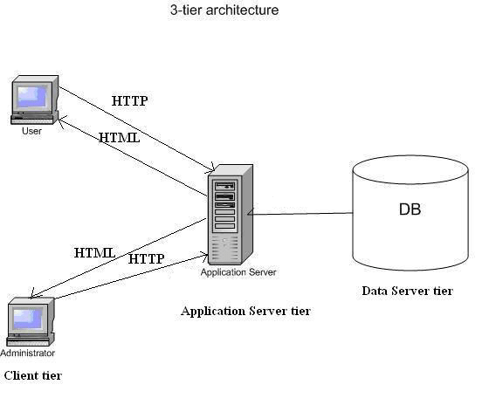

Figure 3.1: Three Tier Architecture

### **The 3-tier Architecture**

In this architecture, there are 3 main elements:

1. The client tier, that is responsible for the presentation of data, receiving user elements and controlling the user interface. Static or dynamically generated content rendered by the browser (front-end).
2. The data server tier, that is responsible for data storage. A database, comprising both data sets and the database management system or RDBMS software that manages and provides access to the data (back-end). For this work, Microsoft SQL 2012 environment will be use.
3. The application server tier, that is responsible for the business logic of the system.

In fact, business-objects that implements the business rules "live" here, and are available to the client-tier. Can also be refer to a dynamic content processing and generation level e.g., Java EE, ASP.NET, PHP, ColdFusion platform (middleware). This tier protects the data from direct access by the clients. For this work, ASP.NET will be use.

Advantages of Three Tier Architecture

1. High performance, lightweight persistent objects
2. Scalability: Each tier can scale horizontally.
3. Performance – Because the Presentation tier can cache requests, network utilization is minimized, and the load is reduced on the Application and Data tiers.
4. High degree of flexibility in deployment platform and configuration.
5. Better Re-use.
6. Improve Data Integrity.
7. Improved Security – Client is not direct access to database.
8. Easy to maintain and modification is bit easy, won’t affect other modules.
9. In three tier architecture application performance is good.

#### **The Client Tier**

The client tier was design using HTML, CSS, JavaScript, JQuery XHTML generated from Asp.net front end. This is shown in the appendix.

#### **The Data Server Tiers**

Microsoft SQL will be used to create a robust database for this project. A relational database is a type of database management system (DBMS) that stores data in the form of related tables. Relational databases are powerful because they require few assumptions about how data is related or how it will be extracted from the database. As a result, the same database can be viewed in many different ways. The most common options when choosing a DBMS are Sql, MySQL and PostgreSQL. Table 3.1 showed the summary of the pros and cons of these database systems: The main difference between these three systems is that MySQL and PostgreSQL are open source while Oracle is not. Oracle offers more advanced functionality than the other two systems: it is the fastest, supports transactions (sets of basic operations considered as single operations) and has enterprise-level data protection and distribution capabilities, such as full-scale clustered replication. On the other hand, of all open-source database solutions available, MySQL is the most impressive as it requires low machine requirement and easy to setup.

|  |  |  |
| --- | --- | --- |
| Microsoft SQL | Mysql | PostreSQL |
| **Pros**  - Fastest commercial DBMS  -Writers never blocks readers  requirements  - Transactions, rollbacks and subselects support. | - Open source  - Low machine  - Easy to setup | - Open source  - Easy to administer  -Transactions and  rollbacks support |
| **Cons**  - Not open source (Oracle  licenses are expensive) | - No transactions, rollbacks and subselects. | - No support to fault tolerant installations. |

Table 3.1: Table summarizing the pros and cons of the major database system. [1]

#### **The Application Tier**

## **UML Diagrams**

Here the **aim** of the **use case diagrams** is to capture the dynamic aspect of our FTS/DMS system. They provide a simplified graphical representation of what the system should do in a **use case**.

### **Use Cases**

Use cases are “a description of set of sequences of actions, including variants, that a system performs that yield an observable result of value to an actor”. They are used in order to: design system from user’s perspective, communicate system behavior in user’s term and enumerate all externally visible behavior. Figure 3.2 and figure 3.3 showed the use cases for this work (there are two actors for the system: a normal user and an administrator).

As shown in the figure 3.2, a normal user can login to the system, download available document, upload a document, edit a document and send document to another user. The super-administrator, on the other hand, can also login, create department, create new users, and manage user’s account (e.g. disabling a user and deleting a user account), edit system configurations, backup systems information and database, manage user log (i.e. view user logs and view documents activity logs) and perform all other function a normal user can perform.

Administrator

Figure 2 - A use case diagram of the Administrator (Super-Administrator)

This module allows the Administrator to create, modify and delete departments. Also allows the managing of users, files and all other configurations. As you can see from the figure above the actor of this case is the administrator and in order to do any action, a user must be logged in as Administrator. When the job is done, he/she has to sign out from the system. Below are the main scenarios of this module:

*Scenario 1:* User logs in as the system Administrator. The system authenticates him/her if it is the system administrator so that the new arrived files tab is shown to him/her. There the Administrator have two choices in front: to accept or to reject a new arrived file. If the file is rejected, it will prompt a message where it asks to write a reason of rejection. In the other way, if the file is accepted it will move to the below section where the Reply, Download, or Upload file back to the system. After the job is done, he/she needs to sign out from the system.

*Scenario 2:* Considering that a user has logged in as Administrator, he/she goes to the Departments. There, the Administrator have a privilege to create a new departments, edit existing departments and delete them. If no need for further actions, the user have to sign out.

*Scenario 3:* After the system has authenticated the user as the Administrator, user goes to create new memo tab and select internal or external memo. If internal memo tab is selected, the administrator will have to select document type and department he/ she which to send the memo to. If no need for further actions, the user have to sign out.

*Scenario 4:* After a successful login as the Administrator, user goes to the View Memo tab where new arrived memo from other users are shown to him/her. There, he/she can compose a memo and send to a specific user, can reply to a memo or can review other income or sent messages. After the job is finished, he/she have to sign out from the system.

*Scenario 5:* User logs in as the Administrator. Goes to the Users tab where all existing users and their information are shown to him. In this tab he/she can create a new user, edit or delete an existing one and can give specific user privileges to them. If no other action is to be taken, he/she has to sign out from the system.

Department User

Figure 3- A use case diagram of Head of Department

The actor of this case, as you can see from the figure above, is the Department user who in most of the cases is the Head of Department. In this module, the Head of Department is allowed to create, send for archiving and manage incoming files. He/she also have access to all his/her outgoing memo. After the job is done, the user have to sign out from the system. Below are shown some of the main user scenarios of this case:

*Scenario 1:* User logs in and the system verifies if the logged one is the Head of Department so that the new arrived memo tab is shown to him/her depending on the department of the user that sign in into the system. After taking his/her decision of what to do with that file, the user have to sign out from the system.

*Scenario 2:* User logs in as Department user. Goes to the Outgoing memo tab where his/her created files/memo are shown. There he/she can see the status of the file and because a creation privilege is given to him/her also from the administrator, he/she can create a file too. After the file is created, it can be send to another user in another department as the case may be. If no need for further actions, the user have to log out from the system.

*Scenario 3:* After a successful login as the Head of Department user and navigate to the

View All Memo tab, all treated and untreated memo are shown to him/her. There the user can reply and send message to other users. After the messages are sent and no other action have to be taken, he/she has to log out from the system.

Secretary

Figure 3.4 - A use case diagram of Head of Department

This module is the module with a fewer privileges. Its main actor is the Secretary user. It allows the Secretary to send for archiving and manage incoming and outgoing files/memo. A file creation privilege is not given to this module, so the user of this module cannot create his/her own files, instead can manage the incoming ones. As the other modules when the job is finished, here also the user has to log out from the system. Below are some of the main Secretary User scenarios of this case.

*Scenario 1:* User logs in and the system checks if it is the Secretary user. When a login is completed, the Dispatch and income files are shown to him/her.

1. **SEQUENCE DIAGRAM**

Secretary

FILE/MEMO DB

User’s Account DB

User Login

FILE/MEMO

Username/Password Check

Username/Password Correct/incorrect

Create Incoming/Outgoing Memo

Create Memo/File

Request Login

Return Dispatch Memo

Return Memo Created

Send Memo/File

Return Status Message

Logout

In the figure above a sequence diagram for file management is shown. A road from creation, through forwarding till the archiving of file is explained. As you can understand firstly a file/memo is created from the Administrator or Head of Department User, the user logs in as head of Department user who views if there is any newly arrived memo. Other than archiving, if file needs to be reviewed from the Secretary also, the Department user forwards it to the Secretary user where he/she has to review it and forward it to the appropriate Department for archiving. In the other hand if the file gets the final hand from the Secretary user and no need for further modification, he/she can send it for archiving to the Head. From here, all the responsibilities for that file are Departmental Head responsibilities.

# 3.8 Class Diagram

Department (Head)

Administrator

Modify Department

Create New Department

+ Departmentname

+ DepartmentCode

+ Create User

+ Edit/Modify User

+ Delete User

+ Add Department

+ Edit/Modify Department

+ Delete Department

+ Create Memo

+ Send Memo

+ View all incoming/Outgoing memo

Create New Memo

+ MemoId

+ Subject

+ Body

+ From-Department

+ To-Department

+Upload Document

+ Download Document

Figure 5 department management class diagram

The figure above is a class diagram of department management. It shows the relationship between the Administrator, Department and Creation of memo. Other than this it shows the model elements such as classes and types.

# **CHAPTER FOUR IMPLENTATION**

In order to make this web application and optimize it to work in fastest and best manner, the 3-tier architecture has been used. Most of the work (programming) is done in ASP.NET because it gives a lot flexibility to the user (programmer) by providing a lot of functionalities and possibilities. Also it is considered as one of the most used programming languages.

For structuring database the SQL has been used because it is one of the most powerful database and it is widely used. HTML and CSS are ones that are used to structure the design of this web application. They are quite easy in implementing and provide a lot of functionalities. Jquery and Javascript has been used in order to create some interactions on the web application.

## **System Hardware**

The following hardware resources are needed to be put in place in order to power the application:

* A host for the system and clients to connect to it via intranet.
* Pentium IV Computer (2.6 GHz processor’s speed)
* 20GB or more hard disk space requirement
* 1GB or more RAM
* A high speed intranet connection
* 1024*74 pixel screen resolution
* Mouse
* Keyboard

## **System Software Requirement**

* Any operating system that support GUI e.g Windows 7, 8 or 10
* Microsoft Visual Studio 2012
* IIS 7
* Browser such as (Mozilla Firefox, Google Chrome, internet explorer)

## **Data Source**

For this work data was source from the following:

* Different departments of Joint Admissions and Matriculation Board (JAMB)
* The internet to research closely related works
* Libraries
* Advance Programming in Visual Studio

## **Database Structuring**

The key to any web or software application is Database. You can't get any application you want without the database. Structuring a database and optimizing it plays a major role in any application. Good database structuring means good normalization that reduces useless data and database redundancy.

|  |  |  |  |
| --- | --- | --- | --- |
| MemoID | int | PRIMARY_KEY | AUTO_INCREMENT |
| Subject | varchar(500) | Checked |  |
| MemoBody | varchar(MAX) | Checked |  |
| DepartmentfromID | int | Checked | FOREIGN_KEY |
| DepartmentToID | int | Checked | FOREIGN_KEY |
| MemoUsrID | int | Checked | FOREIGN_KEY |
| UploadPath | varchar(100) | Checked |  |
| StatusID | int | Checked | FOREIGN_KEY |
| DocumentTypeID | int | Checked | FOREIGN_KEY |
| PriorityID | smallint | Checked | FOREIGN_KEY |
| CreatedBy | varchar(50) | Checked | FOREIGN_KEY |
| RecievedBy | varchar(50) | Checked | FOREIGN_KEY |
| DateCreated | datetime | Checked |  |
| DateTreated | datetime | Checked |  |

Table 4 Overview of Memo Table

|  |  |  |  |
| --- | --- | --- | --- |
| UserID | int | PRIMARY_KEY | AUTO_INCREMENT |
| StaffID | varchar(6) | Unchecked |  |
| FullName | varchar(MAX) | Checked |  |
| Password | varchar(MAX) | Checked |  |
| RoleID | int | Checked | FOREIGN_KEY |
| Designation | varchar(50) | Checked |  |
| DepartmentID | int | Checked | FOREIGN_KEY |
| CreatedBy | varchar(50) | Checked |  |
| DateCreated | datetime | Checked |  |

Table 5 Overview of Users Table

|  |  |  |  |
| --- | --- | --- | --- |
| DepartmentID | int | PRIMARY_KEY | AUTO_INCREMENT |
| DepartmentCode | varchar(50) | Checked | DepartmentCode |
| DepartmentName | varchar(50) | Checked | DepartmentName |
| CreatedBy | varchar(50) | Checked | CreatedBy |
| DateCreated | datetime | Checked | DateCreated |

Table 6 Overview of Department Table

## **SERVER SIDE**

C#, which is ASP.Net framework is used to maintain the functionality of the FTS. With C# the code is cleaner and easy to be maintained, especially when working with big and complex web applications.

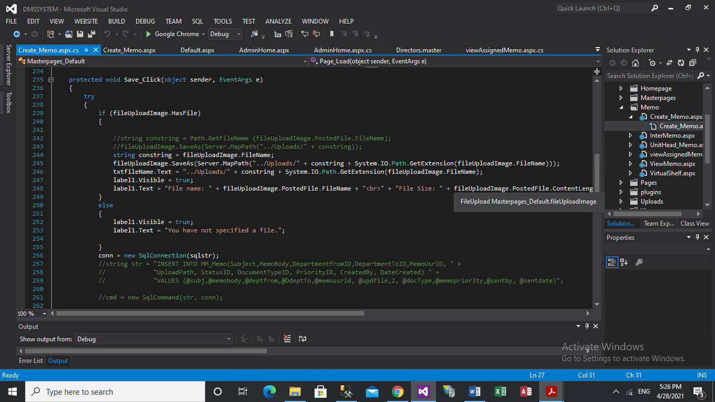

Figure 6 Data Layer

This contains methods that help the business layer to connect with the database. The function makes a validation upon a creation of new file, creates a new file or gives the error. When a new file is created it logs the behavior of that file in the database.

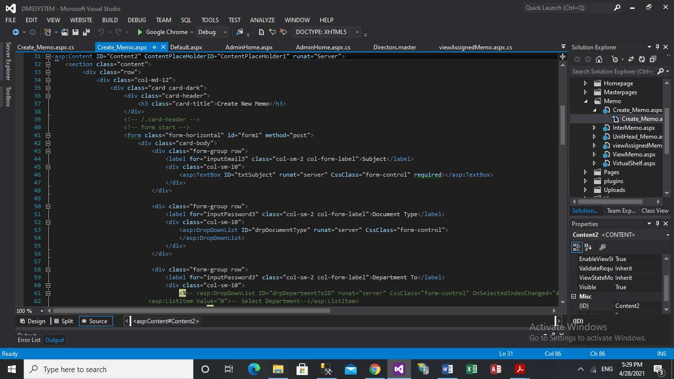

Figure 7 Business Layer

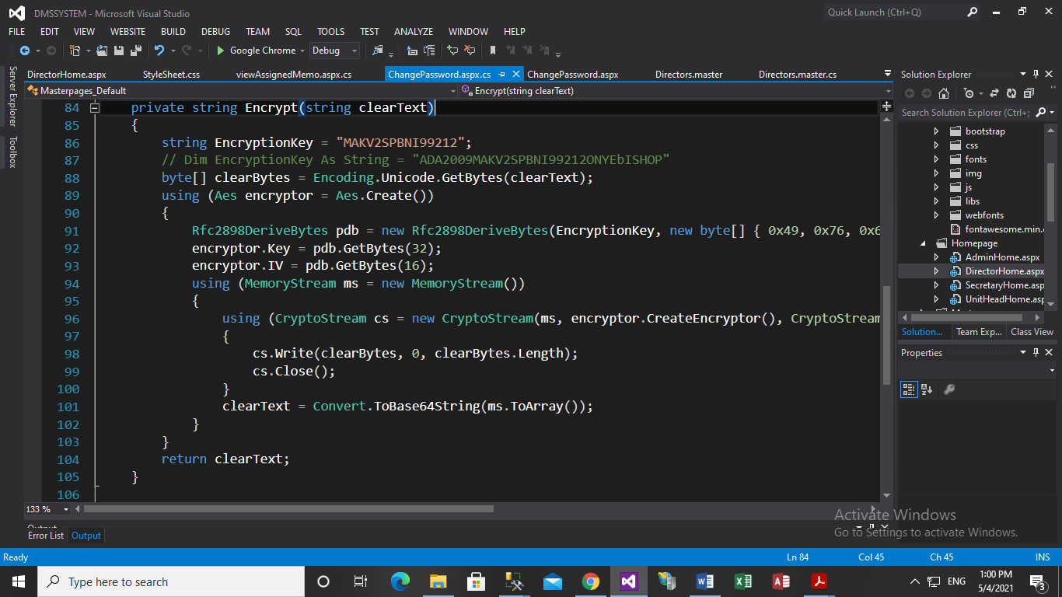

Figure 8 Password Encryption

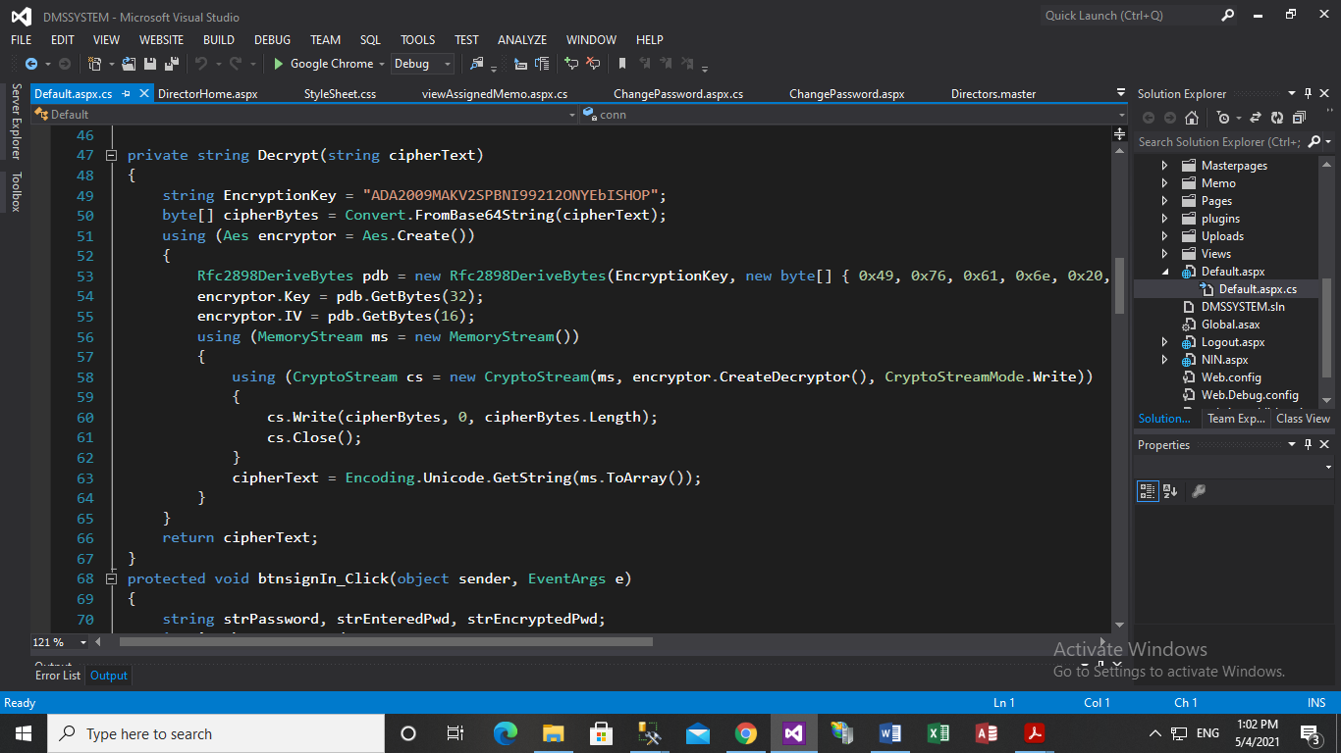

Figure 4.7 Password Decryption

* 1. Demonstration

When FTS/DMS loads it will prompt a login form in which requires the user to enter the username and password.

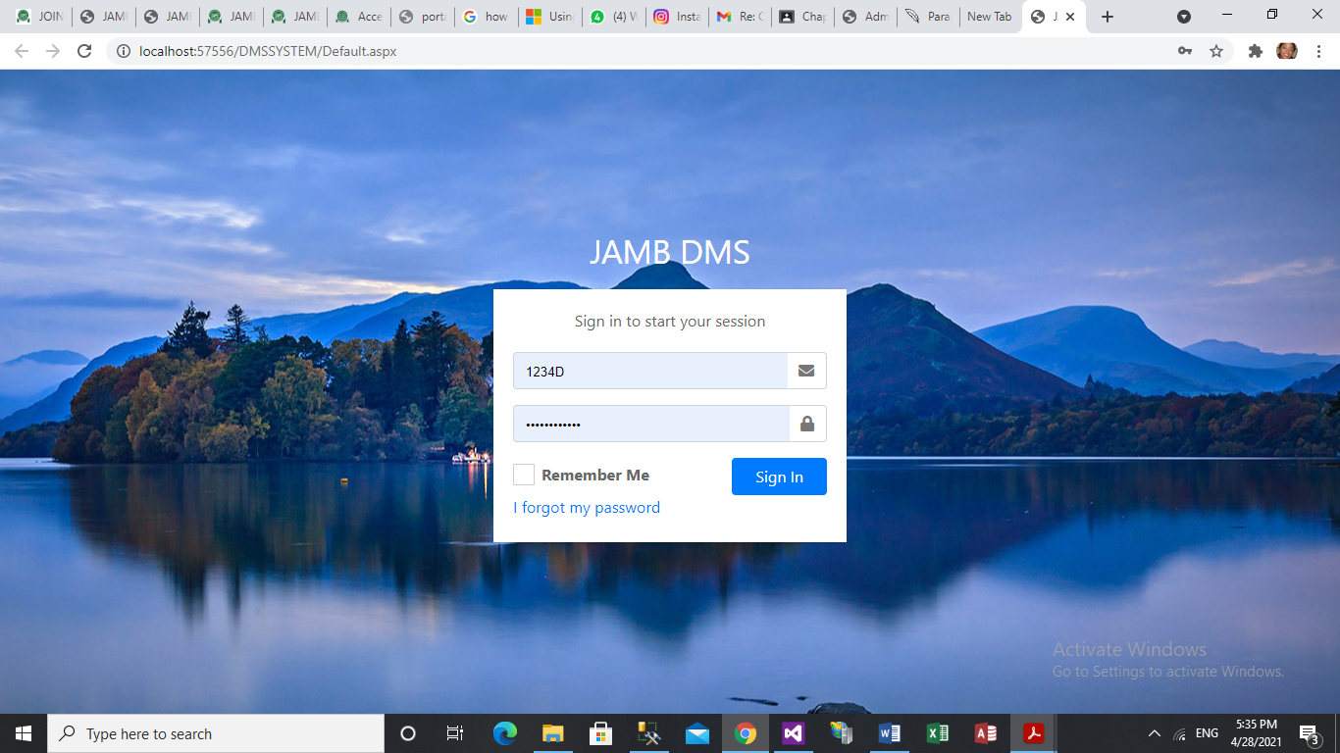

Figure 4.8 Login Form

When the user supply the username and password, the system checks if the password entered is the same has the password created by the admin, if the password is the same the system will force the user to change password, here the user will be redirected the to change password page as depicted in the figure (see fig.4.9).

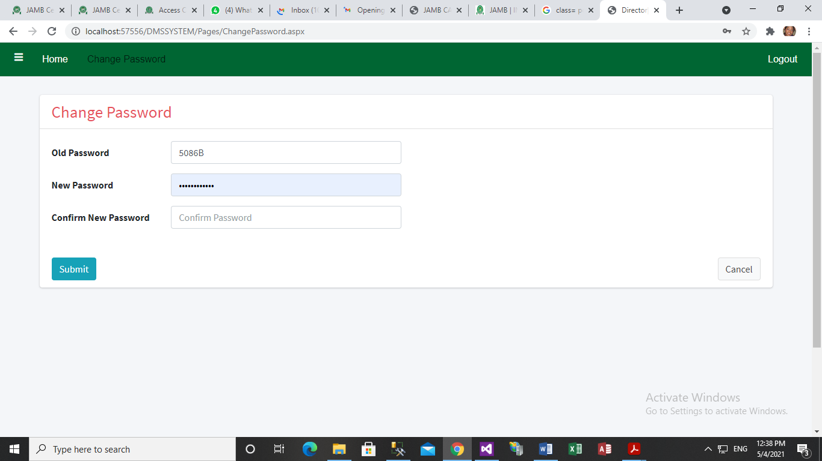

Figure 4.9 Change Password Form

Change Password Page: Here the system checks if the entered password has been encrypted for security purpose and update the requested change password for the login user. Upon a successful login, depending on the user credentials, the Dashboard of income, treated and untreated memo will be shown (see fig.4.10). The current user have full privileges, other than viewing or rejecting income file/memo, he/she can also archive that file directly.

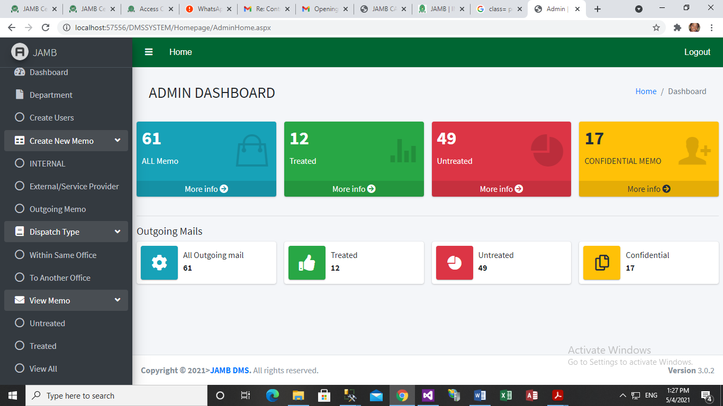

Figure 4.10 Dashboard of user with all privileges

A Dashboard: This is a page that is generated after a successful login by the User or Admin having duly added to the system; it has all the menus that can be used to access all the systems functions as shown in figure 4.10. On this page, the user is given the chance to logout his account to avoid unauthorized user from accessing his/her account.

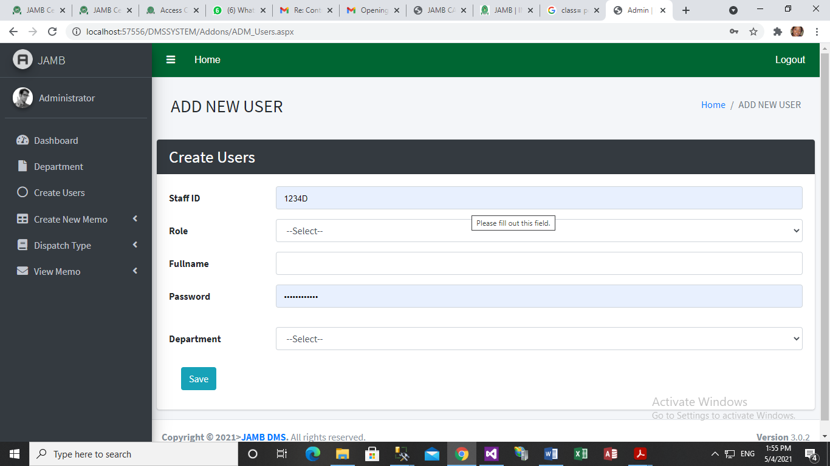

Figure 4.11 Create User Form

Add Users: this page allow admin create/add new user that will be allow to use the system as shown in figure 4.11

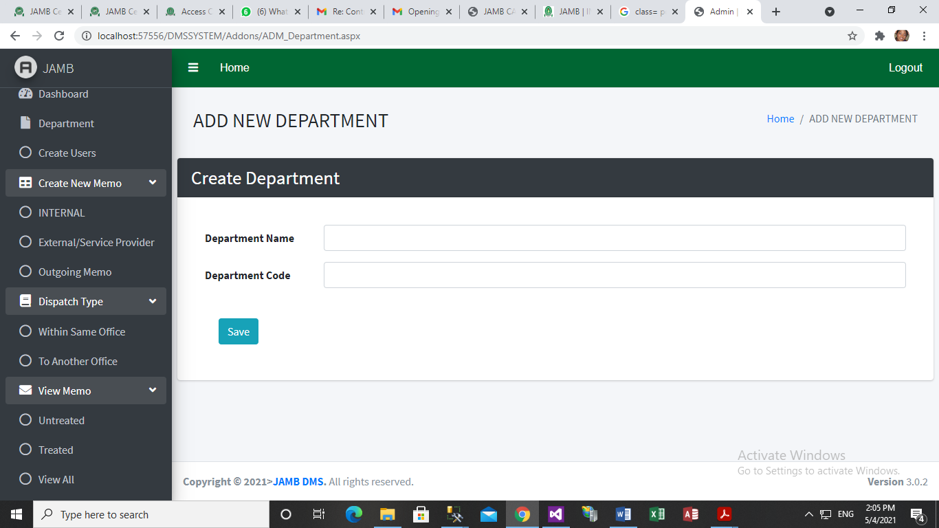

Figure 4.12 Create Department Form

Add Department: This page allow admin to assign a user already in the system to a department, this is depicted in figure 4.12

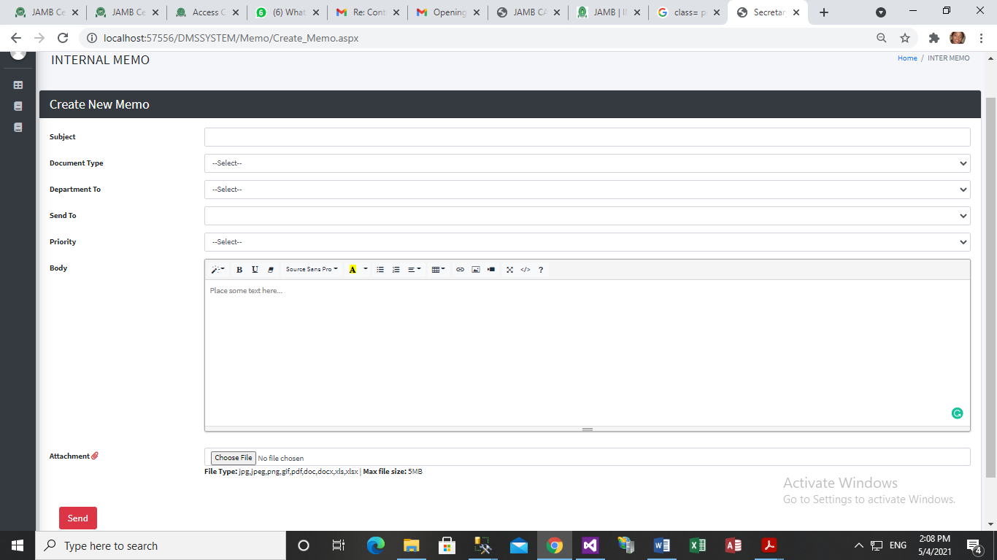

Figure 4.13 Create new Memo

Create New Memo: This is where documents can be send as an email to another user, also the user can upload document into the system if he/she desired to as shown in figure 4.13.

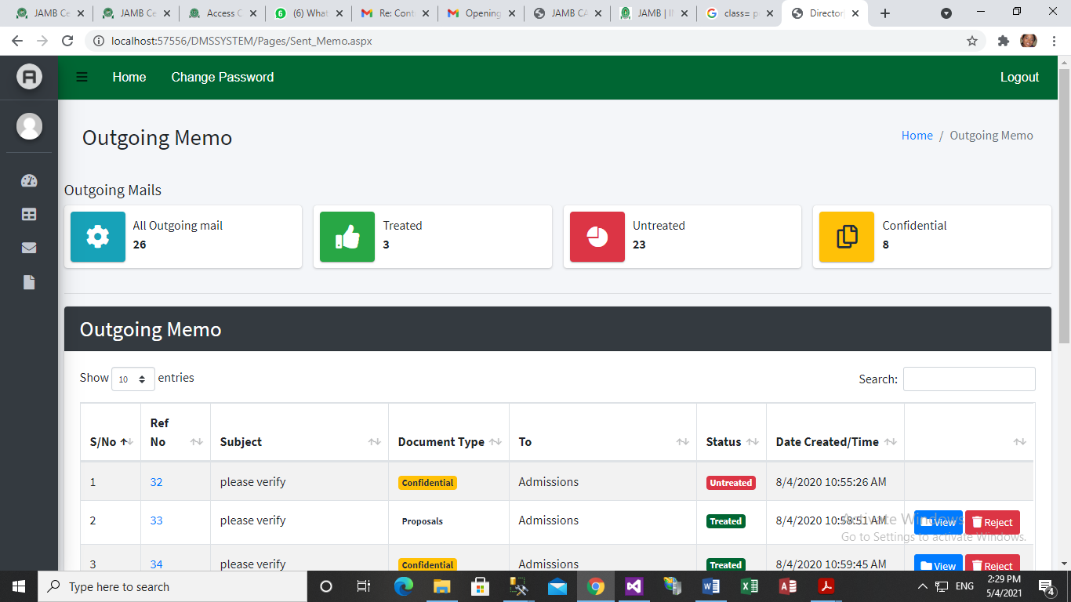 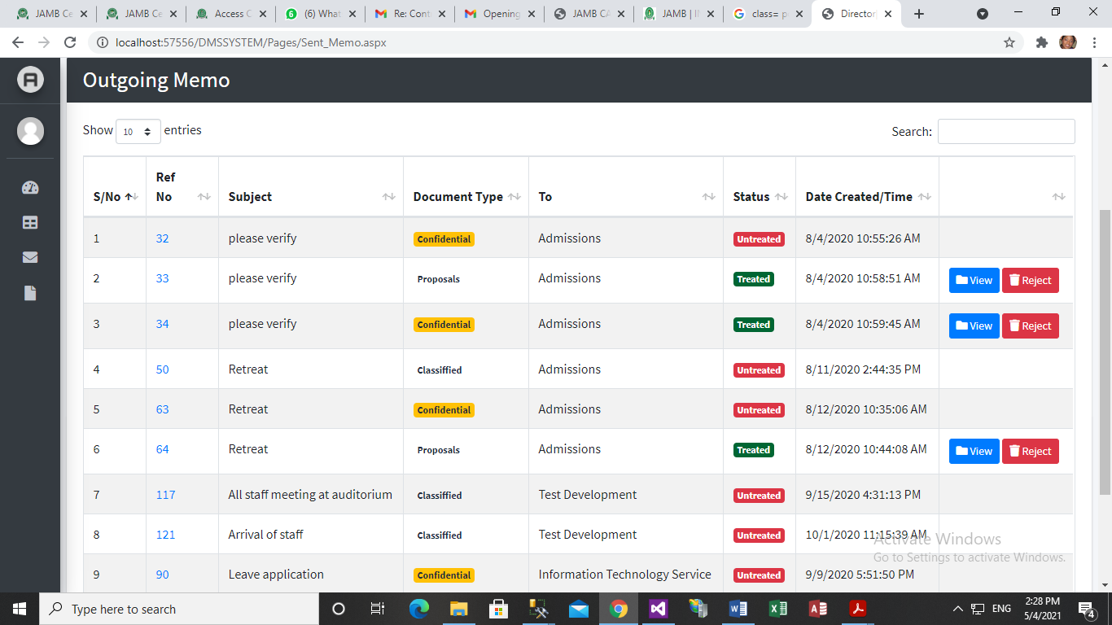 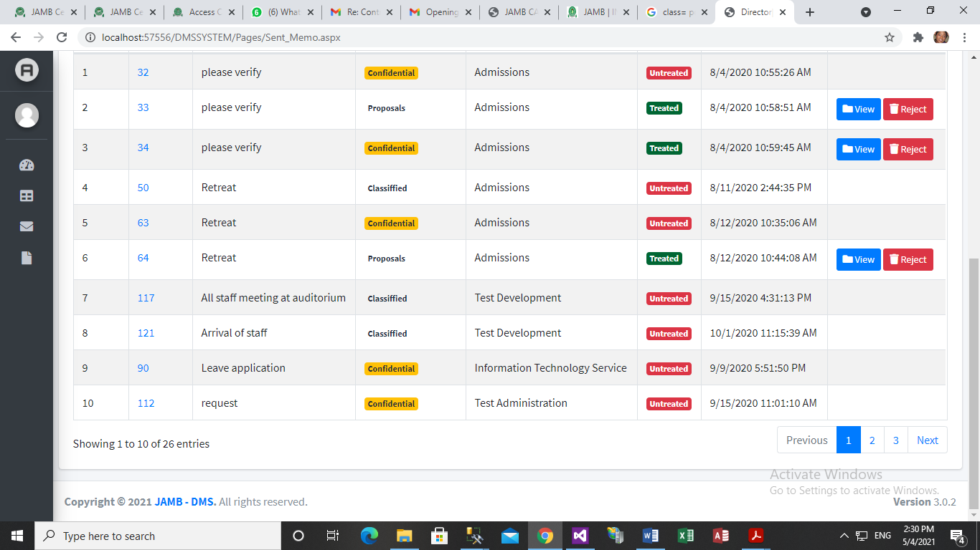

Figure 4.14 Outgoing Memo Page

Outgoing Memo/file: This display in a grid the list of all memo that has been sent out to different users in the system.

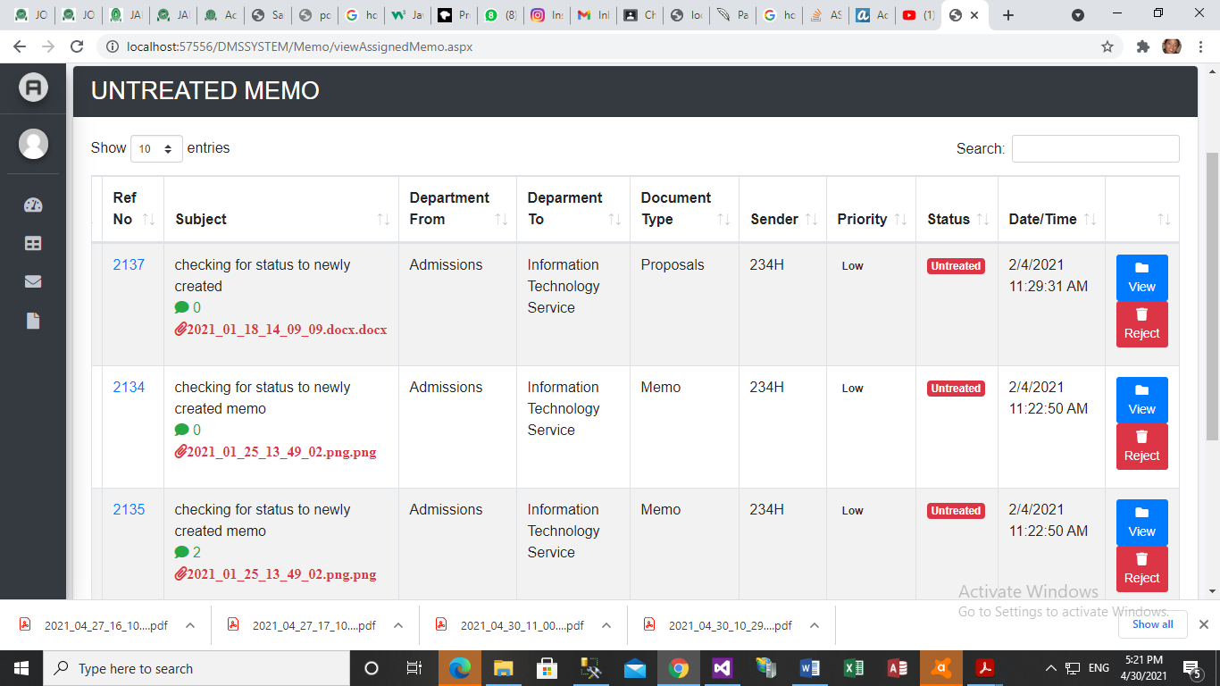

Figure 4.15 Live tracking of files on work

View Incoming Memo: For every incoming file user have two choices: Reject and view the file. In case of rejection the user has to write the reason of rejecting a file (see fig.4.16) while in viewing case actions, the user reply to sender of the memo as see in (see fig.4.17).

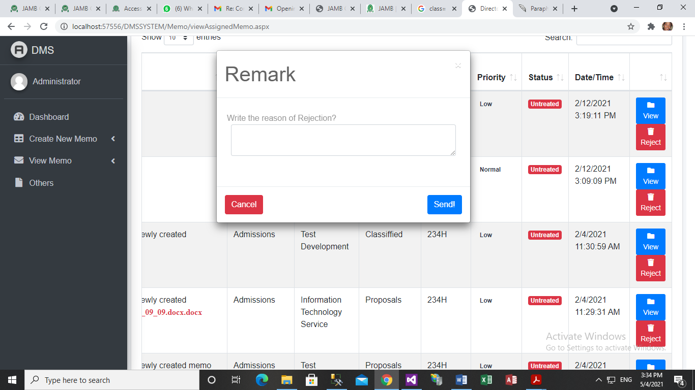

Figure 4.16 Remark Page

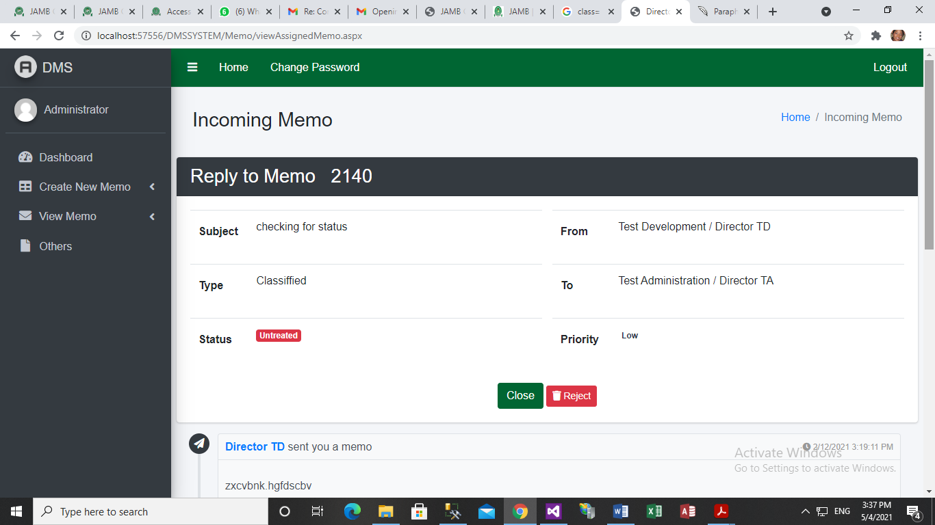

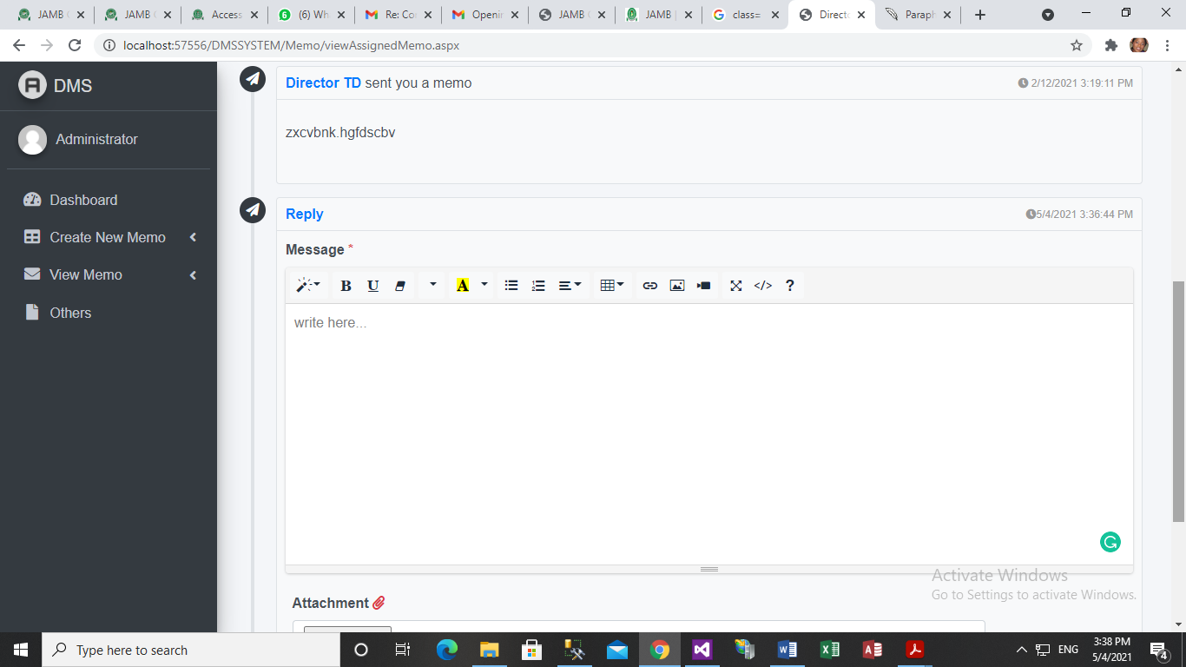

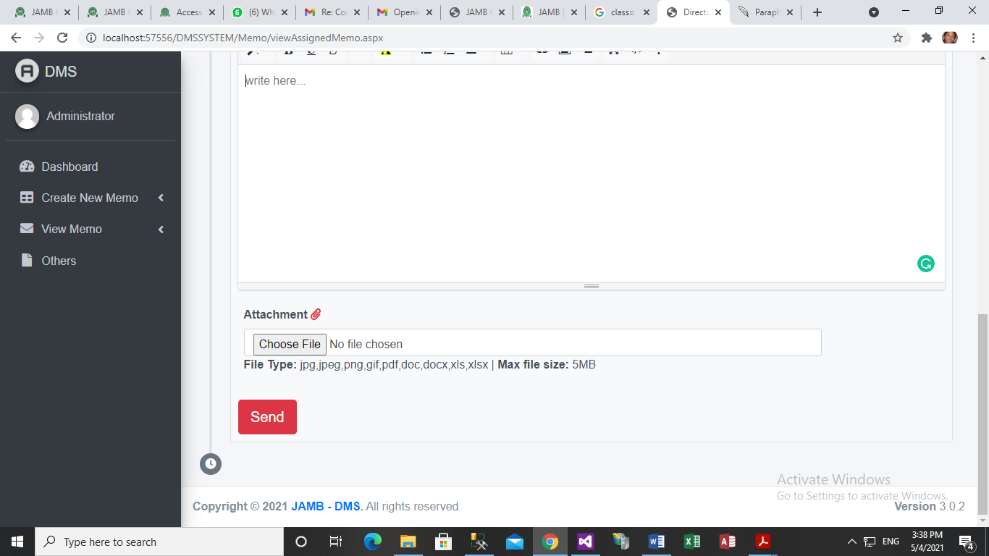

Figure 4.17 View Incoming Memo Page

# Evaluation Result

The purpose of this work is to design a file tracking/Dispatch Management System which will enhance security and reduce space used by documentation of JAMB. There a study was ran to evaluate the technical aspect of the work and user interaction with the system.

## Technical Evaluation

An accredited user now logged in into the system, the user’s password was decrypted and we have our decrypted password back as it was in the original password that was encrypted. Upon successful login to the system a sample Memo/File was created and Microsoft word document, PDF and PNG file was uploaded into the server and was opened in the server file system to check the effectiveness of the system.

## Users Evaluation

Because this system is interactive in nature, technical evaluation and performance measures are not sufficient for the evaluation process. Therefore, a user study will be conducted to evaluate the system in action. The goal of this study is to confirm the feasibility of using the tool and to highlight points of failure that need to be addressed in future implementations.

## Method

Prototype of the system will be setup on three different desks and computers in separate offices. Users can login into the system from there various office, a secretary and one Admin staff. Each will be allowed to use the system for a week. An interview will be conducted from the user to collect a qualitative data based on the experience that each user had while using the system.

## 4.7.2.2 Result

All users were delighted that their documents could be documented automatically and that their documents should be made safer through this system. The system facilitated the search, safe storage, sharing of documents, and lower stress. One user pointed out that he would spend several minutes trying to find documents from the large stack of documents available. In any important note that needs to be added to be noted for the intended user prior to the use of the document, users were able to provide comment on any document. Users stressed the advantage of having the system embedded into daily operation as participants realized the benefits of this system in keeping track of their documents and ensuring the document is securely safe from unauthorized personnel.

**CHAPTER FIVE**

# **CHAPTER FIVE CONCLUSION AND RECOMMENDATION**

This chapter gives a summary of results, conclusion and recommendation based on the results and findings of the work. This chapter gives suggestion for future research related to this work.

## **Conclusion and Summary Result**

This paper has discussed about a Web Application which aims to serve the Joint Admissions and Matriculation Board (JAMB) to reduce their paper work. The goal of this web application is to improve file management, increase staff efficiency, save staff energy and time, reduce cost and improve the work efficiency by using the latest and fastest technologies. The one important thing that needs to be mentioned in this conclusion is that from the research I have done on file tracking systems, there is no file tracking system developed or implemented for Jamb as organization at all. There are some file tracking systems used for some other purposes (ex: governmental purpose) implemented in few countries, however they are also some simple ones who tracks only receipts. Hence, I took this condition as a challenge and hope that the project I am developing will have a massive usage worldwide in the near future. Other than this, I am planning to improve this web application with new and powerful functions in the future works.

## **Recommendation**

Considering the geometrical advancement in the information technology world and the large number of documents that are being handled by organizations daily combine with the need for accountability and proper document management, it is therefore highly recommended that the organization implement DMS. There are high economic advantages attached to this software on the part of the organization and users. Above all, it is user-friendly and documentation should be checked in case of future modification.

## **Contribution to the knowledge**

This work will lay a sound background for further research related to ASP.NET Version of Dispatch Management System with improve security and space management features. This work will enhance the understanding and need for users to ensure security and integrity of document used by them. Also, this work will protect document from unauthorized access and malicious attack thereby creating room for accountability (since document will secure, un-tampered and can be accessed by only authorized personnel overtime) and give confidence and reliability to individuals and organization using the DMS.

## **Suggestion for future research**

One of the improvements in the future will be a cross platform where I will develop a mobile application of this version so the users could access their files also from their smart phones. Another implementation that I am planning to do is also to make this file tracking available not only for Jamb but also for hospitals, police stations and for all other companies that have a lot of paper work. Fingerprint verification can be researched to be added as authentication mode of accessing the system such that the user authentication medium will be by fingerprint scanning, because user might be careless with the password and should a user who is an admin be careless with his password he will void the effectiveness of the system. So as much as this web application improves, that much paper work time and energy will be reduced and automatically trees will also be saved.

# REFERENCES

1. Anderson, R. J. (2001): Security Engineering: a guide to building dependable distributed systems. First edn. Wiley Computer Publishing.
2. Akashah, P. A., Syamsul, R., Jusoff, K. & Christon, E. (2011). Electronic Document Management System. World Applied Sciences Journal (Special Issue on Computer Applications & Knowledge Management), 12: 55-58.
3. Amir, M. B. S. (2007). Document Management System Portal (E-Tanah).
4. Anwar, M. A. & Naseer, A. (2013). An e-Course file management system: A green campus initiative. Vol.3, No.1.
5. Bishop, M. (2003): Computer Security - Art and Science. First edn. Addison Wesley.
6. Das, D., Lanjewar, U. A. & Sharma, S. J. (2013). Design an Algorithm for Data Encryption and Decryption Using Pentaoctagesimal SNS. International Journal of Computer Trends and Technology (IJCTT), 6: 84-88.
7. Delonti (2014). Retrieved from http://www.delontiuniverse.com:8080/Intranet/ DocMgtHealthcare.aspx.
8. Doccept (2015). Retrieved March 10, 2015 from http://www.doccept.com/features
9. Groenewald, T. (2004). Electronic Document Management: A Human Resource Management Case Study. SA Journal of Human Resource Management.Vol.2, No.1:54-62.
10. Hyperoffice (2015). Retrieved from http://www.hyperoffice.com/intranet-software-solution.
11. Kahanwal, B., Dua, K. & Singh, G. P. (2012).Java File Security System (JFSS).Global Journals Inc., 12: Version 1.0.
12. Kattan, A. (2006). Universal Lossless Compression Technique with Built-in Encryption.
13. Keyes, J. (2012).Social Networking Tools to Transform Your Organization.
14. Kodituwakku, S. R. & Amarasinghe, U. S. (2011). Comparison of Lossless Data Compression Algorithms for Text Data. Indian Journal of Computer Science and Engineering. Vol 1, No 4: 416-425.
15. Kodmelwar, M. K., Agarkar, M., Borle, A., Deshmukh, A. & Bhagat, M. (2012). Document Management System with Enhanced Security. IOSR Journal of Computer Engineering (IOSRJCE), 1:18-23.
16. Logicaldoc (2015). Retrieved March 10, 2015 from http://www.logicaldoc.com/product/ features.html
17. M-Files (2015). Retrieved March 10, 2015 from https://www.m-files.com/en/latest-ecmfeatures
18. Mansoor, E., Shujaat, K. & Umer, B.K. (2013). Symmetric Algorithm Survey: A Comparative Analysis. International Journal of Computer Applications (0975 – 8887) Vol 61, No.20.
19. Mushtaque, M. A., Dhiman, H., Hussain, S. & Maheshwari, S. (2014). Evaluation of DES, TDES, AES, Blowfish and Twofish Encryption Algorithm Based on Space Complexity. International Journal of Engineering Research & Technology (IJERT), Vol. 3 Issue 4.
20. Paperwise (2015).Retrieved fromhttp://www.paperwise.com/glossary-of-terms/.
21. Park, J. & Kim, S. (2010). Design and Implementation of E-Document Encryption System using Hash Algorithm. International Journal of Database Theory and Application, 3: No 3.
22. Pinpoint (2015). Retrieved March 10, 2015 from <http://www.lsspdocs.com/pinpointelectronic-document-management>
23. Wikipedia: http://en.wikipedia.org/wiki/Document_management_system. (Accessed 2015, March).
24. Alessandro, A. (2004). Online Auction System, Unpublished bachelor thesis, University of Bolzano/Bozen.
25. Foundation, “jQuery Project,” 2012. [Online]. Available: <http://jquery.org>.
26. D. Smith, “About Javascript,” 30 October 2012. [Online]. Available: <https://developer.mozilla.org/en-US/docs/JavaScript/About_JavaScript>.
27. P. Pop, “Comparing Web Applications with Desktop Applications: An Empirical Study,” Linköping University, Linköping, 2002.
28. DMD (2010), ‘File Tracking System, User manual”, A project of DMD. 1st Edition, Revision.